Virginia Commonwealth University Autism Center for Excellence (VCU-ACE)
Autism Spectrum Disorders for Paraprofessionals
Module 3

Visual Supports
Slide 1: Introduction
- Everyone uses visual supports to help them throughout the day
- Students with ASD are normally visual learners
- Topics covered in this presentation include:
  - What are visual supports?
  - How are visual supports used with students with ASD?
  - What are schedules?
  - How are schedules used with students with ASD?
Everyone uses visual supports to help them throughout the day. Think for a minute. When you go to the grocery store, is it easier for you to remember what you need to pick up if your significant other tells you the 7 items you need or if the person gives you a written list? Obviously, it is easier if we have the written list!
Students with ASD are normally visual learners. It is often difficult for them to process all of the things they hear. For example, when you tell a student with ASD four directions, they may only hear the first one or the last one but do not process all four directions. However, if you show the student a visual of the four directions, they are more likely to be able to process what you want them to do. They can look at the list to remind themselves what they should be doing.
In this presentation, we are going to talk about using visual supports. We will cover the following topics:
- What are visual supports?
- How are visual supports used with students with ASD?
- What are schedules?
- How are schedules used with students with ASD?

Slide 2: Visual supports
- Visual supports are cues that help the student understand rules, routines, and expectations
- We all benefit from having visual supports
- Visual supports are all around us
- Students with ASD understand messages better when they are presented visually
Visual supports are cues that help the student understand the rules, routines, and expectations. We all benefit from having visual supports! Let’s go back to the example of the restaurants we discussed. What types of visual supports were provided in the restaurant? First, you may have seen a sign that said “open” indicating the restaurant was open for business. Next, we mentioned that you saw a sign that said to wait to be seated. You were also given a menu that may have had both words and pictures in it. If you needed to use the restroom, you saw a sign pointing out where the restrooms were and certainly there would have been a visual cue of which restroom was the men’s and which was the women’s. Visual supports are all around us and help each of us to understand our environments and be more independent.
Students with ASD often understand messages better when they are presented visually and so we will want to ensure their educational environment has a lot of visual supports.
Slide 3: Examples of visual supports

Situation | Visual Support | Outcome
Ethan doesn’t know where to put his backpack in the morning | Picture of Ethan’s backpack over the hook where he hangs it | Ethan now knows that his backpack belongs on the hook under the picture
Pamela seems to get overwhelmed when she is given more than one direction at a time and gets confused in which order to do the tasks | Written directions and a check off sheet with the order of the assignments she must complete | Pamela can check off her assignments as she finishes them and she doesn’t have to ask for directions to be repeated
Max doesn’t stand in line well when the class is getting ready to leave for the next setting, such as lunch or resource class | The teacher places feet on the floor with Max’s name on them to show him where to stand | Max now stands in his place and waits for the line to move. He also isn’t pushing others to get into a different spot

There are a number of ways we can provide visual supports to help the student to understand and be more independent. Here are some examples of visual supports that you might see in any classroom. The table also describes the outcomes the visual supports can provide.

Situation | Visual Support | Outcome
Ethan doesn’t know where to put his backpack in the morning | Picture of Ethan’s backpack over the hook where he hangs it | Ethan now knows that his backpack belongs on the hook under the picture
Pamela seems to get overwhelmed when she is given more than one direction at a time and gets confused in which order to do the tasks | Written directions and a check off sheet with the order of the assignments she must complete | Pamela can check off her assignments as she finishes them and she doesn’t have to ask for directions to be repeated
Max doesn’t stand in line well when the class is getting ready to leave for the next setting, such as lunch or resource class | The teacher places feet on the floor with Max’s name on them to show him where to stand | Max now stands in his place and waits for the line to move. He also isn’t pushing others to get into a different spot

Slide 4: Examples of visual supports continued

Situation | Visual Support | Outcome
Braden cries every time he sits at the circle table in the back of the room and asks for snack. | The teacher labels the table with the different activities that occur at the back table so that Braden can see which activity is going to occur | Braden stops requesting snack when activities like reading or art are shown at the back table and only requests when snack is shown
Yvette hits, pushes, and kicks other children on the carpet during circle time | The teacher puts a carpet square on the floor for Yvette to sit on indicating where her body needs to stay | Yvette no longer hits, pushes, or kicks other students as long as they stay off her carpet square
Anthony throws his worksheet on the floor after five to seven minutes of work | A visual timer is set for four minutes so Anthony can see he can stop working after the timer goes off | Anthony works for the time on the timer and this time is increase gradually as he is more successful

Here are some further examples:

Braden cries every time he sits at the circle table in the back of the room and asks for snack. | The teacher labels the table with the different activities that occur at the back table so that Braden can see which activity is going to occur | Braden stops requesting snack when activities like reading or art are shown at the back table and only requests when snack is shown
Yvette hits, pushes, and kicks other children on the carpet during circle time | The teacher puts a carpet square on the floor for Yvette to sit on indicating where her body needs to stay | Yvette no longer hits, pushes, or kicks other students as long as they stay off her carpet square
Anthony throws his worksheet on the floor after five to seven minutes of work | A visual timer is set for four minutes so Anthony can see he can stop working after the timer goes off | Anthony works for the time on the timer and this time is increase gradually as he is more successful

Slide 5: Visual supports example

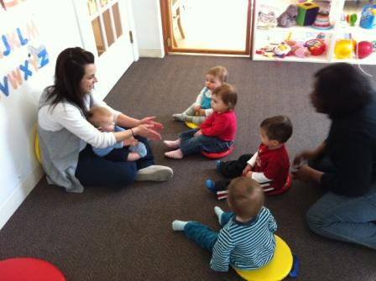

The picture displayed here shows a circle time lesson where each child has a visual support to show where to sit which you can see by their colored circles on the floor. This allows the children to know where their individual space is and not get into other children’s spaces.

Slide 6: Visual supports example
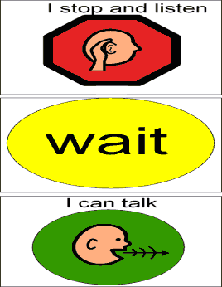
Can you figure out what this visual is used for? This visual support is used to help a student with Asperger’s Syndrome to have a conversation. It provides a reminder to stop and listen, wait, and then talk when talking to another person.
Slide 7: Visual supports example

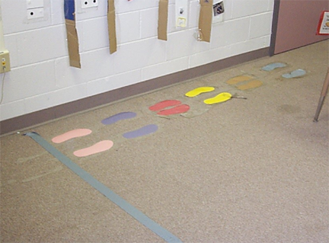

What about this visual support? It is used to help the students know where to stand when in line.
Slide 8: Visual supports example
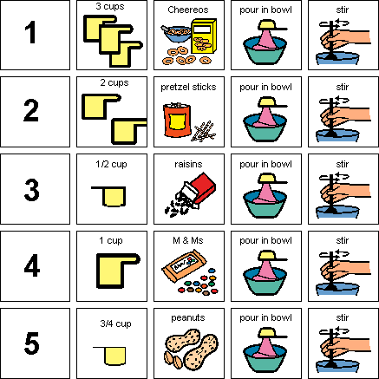

This example may be a bit trickier. This visual support is for a high school student who is learning to make snacks, in this case, is making trail mix. She could not remember the steps, so a visual support was made outlining the steps to making trail mix.
Slide 9: Visual supports example
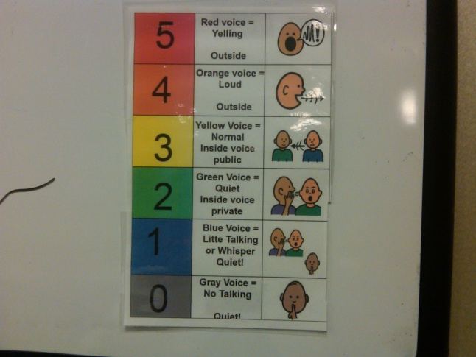
One more example. How do you think this visual support is used?
It is used to help a student remember the volume of his voice when he is in different places. When the student goes to the cafeteria, the paraprofessional can show the student the support and remind her the volume she is to use. Later, when she goes to English, the paraprofessional can use it again to show the appropriate voice level. If at any point the student is using a voice that is too loud or too soft, the visual can be used to help show the student the appropriate volume.
Slide 10: Visually structuring work

- Visual supports can be applied to academic instruction too!

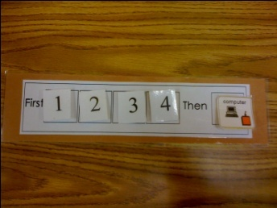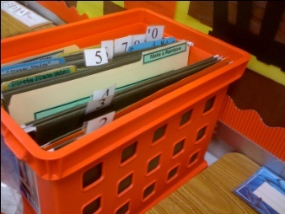

As you can see from our examples, visual supports can be used in many different ways. Let’s talk a little more about how to apply visual supports to work tasks and instruction. We can organize the student’s work visually so the student will know what work needs to be done and the order to complete the work. There are many different ways to organize the work. There is really no right or wrong way, as long as it works for the student. Here are a few examples.

The picture on the left shows the visual organization of the work to be completed. The student with ASD will start on the left hand side with number 1. He will find a folder with the number one on it and complete it. The picture on the right shows the bin where the work is located. The student simply takes the number 1 and matches it to the folder that says number 1. He takes the work from the folder and completes it before moving to task number 2.
He will work his way through the tasks until the last task, number 4 is completed. Once task number 4 is completed the student receives a break on the computer.

Can you see how this would help the student to understand what he has to do and when he can have a break?

Slide 11: Visuals for instruction
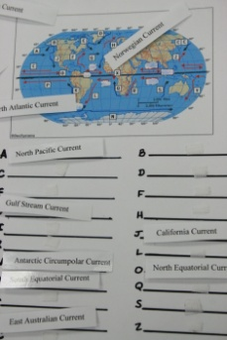

Here is another example of how visuals can be used to help the student understand the academic instruction. In this picture you can see how a worksheet was changed and made visual for a high school student. The student is learning the same material as the other students and is learning about ocean currents. She is completing the same task as the other students too, but demonstrating her knowledge a different manner.
Slide 12: Visually structuring work example

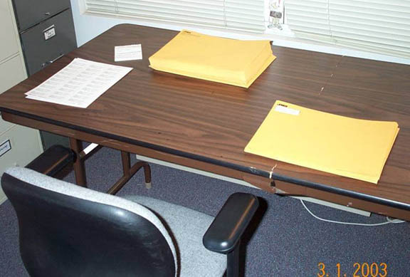
This picture shows another example of visually structuring work for a high school student. The student takes the address labels off the left, places one on the envelope in the middle, then places in a stack on the right side.

Slide 13: Visuals for instruction
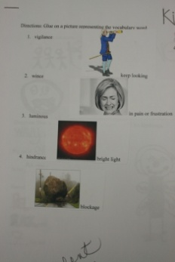

In this example, a vocabulary activity was made visual. The student was given the worksheet, then had to match the picture to the correct sentence.
Slide 14: Visuals for instruction
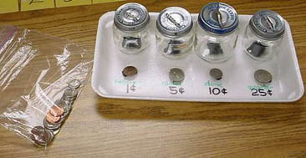

This picture shows how learning coins was turned into a visual activity.
There is no wrong way to do this. You can create a visual out of nearly any learning activity.

Slide 15: Visual schedules
- Visual schedules are a very important and very common support for students with ASD
- This is a visual representation of the student’s daily activities
- Because they do better with visual information, making the schedule into something visual helps them to know what is coming up next and throughout the whole day
- What their schedules look like will depend upon their individual skills and needs

Visual schedules are a very important and very common support for students with ASD! Visual schedules are exactly how they sound. This is a visual representation of the student’s daily activities. It provides a list or pictures showing what the student is supposed to be doing.
Take a moment and think about how you organize your daily activities. Perhaps you have a calendar on your fridge that has all your appointments written on it. Perhaps you have a daily schedule with the meetings and activities you will be doing during the day. Maybe you have an electronic calendar on your phone. Most of us have some kind of schedule that is a personal way for us to organize and remember what we are supposed to be doing. Students with ASD benefit from this too! Because they do better with visual information, making the schedule into something visual helps them to know what is coming up next and throughout the whole day.
What their schedules look like will depend upon their individual skills and needs. Students can use schedules no matter how old they are and the schedule can grow with the student’s needs.
Slide 16: Object schedules
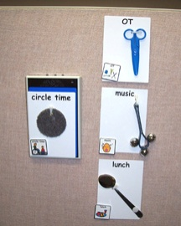

There are different types of schedules that can be used based on the ability of the student. In the next few slides we will discuss different types of visual schedules.
The visual schedule on this slide is an object schedule. If you look closely, you can see that real objects are used to show the student what he is to do this morning. The student can take the object off the schedule and then use the object in the activity they are supposed to do. In this schedule, the student is currently at circle time. He will next go to OT and will use scissors to work on cutting skills. After that he will go to music, then to lunch.
An object schedule is used with students who are just learning to use a schedule.

Slide 17: Picture schedules
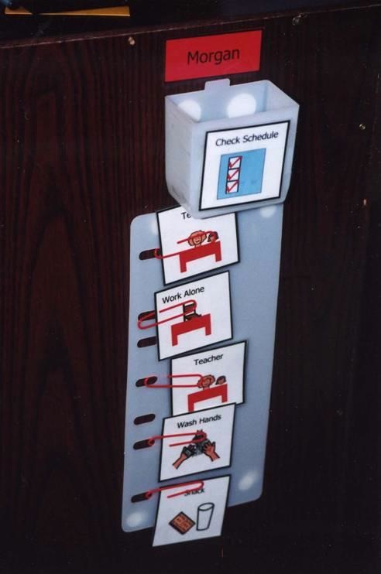

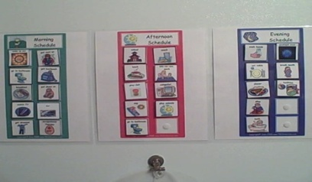

This slide shows a visual that uses pictures. There are 2 different examples. The first has only a few of the student’s activities on it. The student is working with the teacher, working alone, washing hands and eating snack.
The second picture is for a student who can handle a lot more pictures being shown to her at the same time. You can see different time periods for the student including morning, afternoon, and evening.
Slide 18: Video of using visual schedule

- Video: Visual schedule

In this video, you will see how a visual schedule can be used with a student with ASD. At first, you will see that the schedule is very small and only has two items, first a work task and then a reinforcement, in this case, the V-Tech. The video goes on to show how this simple schedule can be expanded over time into a longer schedule which increases the amount of work time in which the student engages.

Slide 19: Video of using visual schedule

Matthew, when you’re finished, you can play!
Typical children with language comprehension abilities will be able to understand the simple instruction. For the child with ASD however, difficulties with comprehension can interfere with the child’s ability to benefit from this kind of verbal explanation. He needs to be given this information in a simple but visual way. For example, when we use a first-then board, the student can see that he is finished with his work, he can have his favorite toy.
First numbers, then V-Tech!
This teacher is showing her student that when he is finished the number activity, he can play the v-tech.
Good, find ten! That’s right, that’s ten!, find 9!
Good job!
Numbers are finished, time for v-tech! here you go!
Over time, the goal would be to increase the amount of time the student is expected to sit and cooperate with a series of tasks.
We’re gonna do piggy bank! Then shapes, then string, okay!
This is the student two months later, now he is able to do three tasks before he needs a break.
My turn!
Last one, my turn!
Good for you, give me yellow giraffe!
Listen, shapes are finished. Time for string.
Good job, put away. Time for toys!
Slide 20: Written schedule

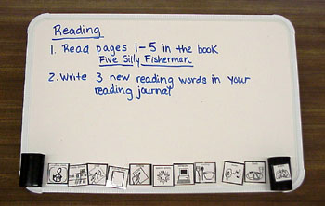
For students who can read, a written schedule is appropriate. In the first picture you can see a written schedule for a student that covers the whole day. In the second picture you can see a different version where some pictures are used, but when it was time for reading, the paraprofessional simply wrote what he was supposed to do. You can see that this schedule isn’t particularly fancy but is effective to show the student what they are supposed to do. A written schedule also allows for you to easily make a change if the schedule should change.
Slide 21: Video: Using written schedule

In this video you will see several examples of written schedules that can be used with students who can read.
Slide 22: Video: Using written schedule

It’s important to remember that visual schedules are more encompassing than just your circle, arts, and crafts, basic type of schedule. They can include things like to do list, grocery lists, anything that is part of your daily activity. This is an example of a written to do list. There are two ways this can be done. The child can go to the first one and check it off, or the child can initial it. After these four activities are done, the child can take a break and the choices are listed at the bottom. The important thing to note about this to do list is that the child is able to see exactly what activities they need to complete, how much work they need to do, and the choices they have after completing this work.
This is an example of a portable written schedule. It lists out on the front of the binder the exact class the child has for that day. As you can see from this schedule, the child is doing pretty well, is very advanced academically, but still is needing a schedule. Once we open this, we see the specific class, the first one being language arts. It gives the room number, then lists the materials that he child will need for that specific class and lists the rules. As we continue on, we’ll notice for this specific schedule that the rules are different which is important to note. This time, it tells the student to find a seat and that you do not get to sit in the same seat every week which is different than the prior classes where they had an assigned seat.
The last page in the notebook allows the student to write down their assignment that they’ll take home for homework and the materials it will take to complete the activity. This will be a good system for a student to who sometimes forgets what materials they need for specific assignments.
Slide 23: First / Then board
- 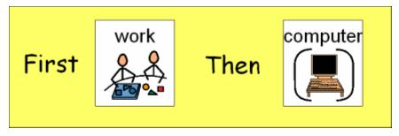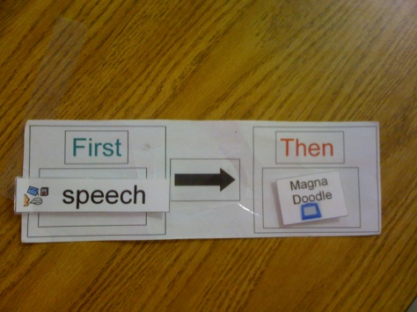
A First/Then board is another type of visual support that can help show the student how long she has to work. The board, as you can see here, is fairly simple. A First/Then board is used to visually represent the task to be completed and the activity that will follow the task. For example, for a student who doesn’t like hand writing but really enjoys the computer, the teacher may put handwriting followed by computer. Essentially saying, first hand writing, then computer. This simple visual increases an individual’s motivation to engage in an activity that may be challenging for them.
Slide 24: Video example of 1st/Then board
- 1st/Then Board http://www.youtube.com/watch?v=1z3Lb0fO6RM
This video example shows the basics of using a First/Then board. This board shows the student has to complete his three boxes for his task and then he gets a break. The break is probably something the student likes.
Slide 25: Video example of 1st/Then board
This is how we use a first then board. We have three boxes. Three boxes—1,2,3 of o activities he has to complete. Then he gets a break. So let’s review, 1,2,3, and then done! Break!

Slide 26: Apply it!

- Think about a student with ASD with whom you work and think about the special or general education classroom where you work.
- Answer the questions about structure.
- Answer the questions about visual supports.

Now it’s your turn. In your documents find the Apply it! document titled: Instructional Strategies and Considerations. Now find the question titled: Classroom Structure and Visual Supports.
Think about a student with ASD with whom you work and think about the special or general education classroom where you work.

Take a few minutes and answer these questions about structure.

- Is the furniture arranged to provide physical structure and help the student understand the environment?
- Is the environment free of distractions?
- Is the environment easy to move around and navigate?
- Does the student know what to do in various places in the room?
- Are the materials organized and accessible for the student?
- List three ways structure may be added to the environment to help the student to understand it better.

Now answer these questions about visual supports.

- What visual supports are used to help the student understand directions?
- What visual supports are used to help the student complete his or her work?
- List three ways visual supports can be used to help the student.

Once you have completed this “Apply it” activity, share your paper with your supervising teacher. Talk with your supervising teacher about the structure in the classroom to get his or her thoughts about the structure and use of visual supports in the classroom.

Slide 27: Summary
- Using visual supports are a very common and very important support for students with ASD.
- Visual supports can help students with ASD to be more successful in their daily life and to be more independent.

Students with ASD tend to be visual learners. Using visual supports are a very common and very important support for students with ASD. Visual supports can help students with ASD to be more successful in their daily life and to be more independent.
Visual supports can include visual schedules, First/Then boards, how you place items in order to use them efficiently, and picture cues for expectations.

Information for this presentation is from Virginia Commonwealth University's Autism Center for Excellence (VCU-ACE) that is funded by the Virginia State Department of Education (Grant # 881-61172-H027A100107). Virginia Commonwealth University is an equal opportunity/affirmative action institution providing access to education and employment without regard to age, race, color, national origin, gender, religion, sexual orientation, veteran's status, political affiliation, or disability. If special accommodations or language translation are needed contact (804) 828-1851 VOICE -- (804) 828-2494 TTY

