Service Intensity and Job Tenure in Supported Employment: Final Report

Gary R. Bond & Marina Kukla

VCU Final Report
December 9, 2009

Gary Bond, Ph.D., was Chancellor’s Professor in the Department of Psychology at Indiana University Purdue University Indianapolis at the time this study was conducted. He is now Professor of Psychiatry at Dartmouth Medical School.

Marina Kukla, M.S., is a doctoral student in the clinical psychology program at IUPUI. She is currently a University of California San Diego/Veterans Affairs Clinical Psychology Intern.

Abstract
Background: The effectiveness of the Individual Placement and Support (IPS) model of supported employment in helping clients with severe mental illness to work in competitive jobs is well established. However, one key component of the model, ongoing support for clients who obtain employment, has not been adequately specified or empirically validated. This study examined three questions: (1) What are the two-year employment outcomes for competitively employed clients enrolled in supported employment? (2) What are the patterns of employment specialist contacts over time? (3) What is the relationship between frequency of employment specialist contact and duration of employment over two years? We hypothesized that intensity of support would be positively correlated with duration of employment.

Methods: Employment specialists from four IPS programs provided monthly data on their contacts with 142 clients with severe mental illness and employment outcomes for a two-year period after each client obtained a competitive job. Using either web-based or hard copy surveys, employment specialist provided information on employment outcomes (i.e., hours worked per week, days worked, wage rate), employment changes (i.e., job starts, job losses, and changes within jobs) and follow-along support provided by employment specialists (i.e., frequency, mode, location, and duration of support).

Results: With regard to employment outcomes, the sample of 142 clients included 21 (15%) who held a single job the entire two years, while 73 (51%) held multiple jobs over follow-up. The sample averaged 9.6 months of job tenure in their initial job and 12.9 months employment during the two-year follow-up period. Clients held an average of 1.92 jobs across two years; for those with multiple jobs, the period of unemployment between the first and second job averaged 2.9 months. With regard to intensity of services, 99 (69%) clients received services over the entire 2-year follow-up period. Employment specialists averaged 1.72 contacts per month; over 75% of all contacts were face-to-face and were made at a variety of locations, including the job site, other community locations, and agency offices. The overall pattern of contact was approximately weekly contact immediately after the job start, with a sharp decline in intensity within a few months, followed by a steady level of approximately one contact per month for the remainder of the two-year follow-up. Analyses examining correlations between employment specialist contact and duration of employment were focused on clients receiving IPS services for the entire 2-year period. Intensity of support was positively correlated with months worked over the two years (r = .27, p < .01), supporting the study hypothesis. Intensity of face-to-face contact was similarly positively correlated (r = .26, p < .01). However, intensity of support was not associated with job tenure in the initial job.

Conclusion: For clients with severe mental illness who have started a job, ongoing support by an employment specialist is modestly associated with subsequent duration of employment. Face-to-face contact may be the most effective mode of contact, but there is no evidence that location or length of contacts influence job tenure. IPS supported employment programs often provide two years of contact after a job start, although typically this contact is once monthly after the client has been successfully employed for several months. Future research should seek to identify the specific characteristics of effective employment specialist interventions, optimal timing of interventions around job transitions and crises, and the complementary roles for mental health treatment and nonprofessional support in promoting job tenure.
Within the vocational rehabilitation field, one success story has been the emergence of the Individual Placement and Support (IPS) model of support employment for clients with psychiatric disabilities (Becker & Drake, 2003). The core principles of this model are (1) a focus on competitive employment (which refer to regular community jobs, with nondisabled coworkers, paying minimum wage or higher), (2) eligibility based on consumer choice, (3) rapid job search, (4) integration of mental health and employment services, (5) attention to consumer preference in the job search, (6) individualized job supports and (7) personalized benefits counseling (Bond, 2004). Because of the superior competitive employment outcomes for clients enrolled in these programs compared to other vocational services (Bond, Drake, & Becker, 2008), this model has been identified as evidence-based supported employment. However, despite consistently strong findings, it has been frequently observed that the strongest findings have been for job acquisition, and that the findings for job retention have been less consistent (Wallace & Tauber, 2004). In other words, the challenge for people with severe mental illness is not so much in finding jobs as in keeping them (Bond, Drake, Mueser, & Becker, 1997).
Ongoing support from a supported employment team has been hypothesized as a key to enhancing job retention of individuals with disabilities after they obtain competitive work. Tracing supported employment back to its roots, one of the original formulations was the job coach model in which the traditional “train-place” vocational rehabilitation approach was replaced with the “place-train” approach, which recognized the need for intensive assistance to clients after they obtained competitive employment (Wehman, 1986). However, the principle of ongoing support for clients with psychiatric disabilities remains underspecified. Specifically, what supports are needed, for how long, and at what intensity, for which kinds of clients, has not been empirically established. The current study aims to provide descriptive and correlational information on the following questions:
- What is the typical intensity of services for clients with psychiatric disabilities enrolled in evidence-based supported employment after they obtain a competitive job? Where and how is this support given?
- What is the time course of this support? Does the intensity decline over time?
- What is the relationship between intensity of support and job retention?
Regarding the first question (intensity of support), several early studies attempted to establish baseline data about the frequency of employment specialist contact in supported employment programs (Bond, Miller, & Dietzen, 1992; Bybee, Mowbray, & McCrohan, 1996; MacDonald-Wilson, Revell, Nguyen, & Peterson, 1991; Rogers, MacDonald-Wilson, Danley, Martin, & Anthony, 1997). These studies yielded widely varying estimates of service intensity, with hours of contact per month ranging from 1.7 (Bybee et al., 1996) to 14.8 (MacDonald-Wilson et al., 1991). Moreover, because these studies were conducted before the advent of evidence-based supported employment, they may have little relevance to current practice.
Regarding the second question (the pattern of support over time), the scant evidence on this issue suggests that service intensity typically declines rapidly after job placement. In the original job coach model, designed for clients requiring intensive training at the job site, services were intended to be “faded” once clients obtained the skills necessary to perform job duties (Wehman, 1986). It has never been clearly established – theoretically or empirically – whether the same pattern of service intensity should hold for people with psychiatric disabilities, most of whom have different service needs. Clearly, the generally accepted view of job support differs for people with psychiatric disabilities, with the bulk of the support provided outside the work place (Becker & Drake, 2003). Thus, the rationale in the job coach model for tapering off support as the client learns the job is not directly relevant to evidence-based supported employment for people with psychiatric disabilities. MacDonald-Wilson and colleagues (1991) found that clients with non-psychiatric disabilities received the bulk of their service hours at the start of services with a gradual tapering off, whereas consumers with psychiatric disabilities showed a rapid decrease in service hours followed by periodic spikes of increased hours. Two other studies have also found a sharp decline in the intensity of service shortly after job acquisition (Anderson, 1999; McGuire, 2005). Of course, another factor influencing the intensity of services is likely to be funding considerations. Since the state vocational rehabilitation system provides short-term funding for clients, it has always been problematic securing long-term funding to pay for ongoing support for clients once they attain a successful closure, ordinarily 90 days after start work (Fraser et al., 2008).
Although the evidence base is strong for the IPS model and even though the IPS model does have clear guidelines for many aspects of supported employment services, quantitative standards for follow-up support has never been specifically prescribed. However, in the recently revised Supported Employment Fidelity Scale, which is used to assess fidelity to the IPS model, Becker and colleagues (2008) recommend this standard: “Employment specialists have face-to-face contact within 1 week before starting a job, within 3 days after starting a job, weekly for the first month, and at least monthly for a year or more, on average, after working steadily, and desired by clients.” These standards, however, are not bolstered by any empirical data.
Regarding the third question (the relationship between ongoing support and job retention), there is surprisingly little direct evidence demonstrating a positive link. McHugo and colleagues (1998) found that clients who continued to receive professional support 3.5 years after entering a supported employment program were far more likely to be working than those who no longer had that support. In two long-term studies, clients who maintained relatively stable employment over an 8- to 12-year period indicated that ongoing professional support was a primary factor in their continued success (Becker, Whitley, Bailey, & Drake, 2007; Salyers, Becker, Drake, Torrey, & Wyzik, 2004). These two long-term studies, however, were based on retrospective self-reports.
Prospective quantitative studies generally have failed to show a relationship between service intensity obtaining a job and job retention. Leff and colleagues (2005) found a positive correlation between job support and job retention in a multi-site study with 1,340 clients receiving either supported employment or services as usual. However, their statistical model did not show a temporal relationship between receipt of job support and subsequent job retention. Their data were also complicated by the inclusion of control subjects who received little job support and may have distorted the study findings. Bond and colleagues (1992) found positive correlations between service intensity and job retention; however, intensity of service provided after job placement was not related to job retention. McGuire (2005) also failed to uncover any strong relationships between service intensity and work outcome once program dropouts were removed. Thus, in all three of these studies, the service intensity-job retention relationship appears to have been shown only when the analyses included clients who never worked at all. In other words, these studies may shown the role of employment specialist assistance in finding work, but all failed to show any influence of ongoing support.
Using a large administrative data set, Jones and colleagues (2001) examined service time recorded by employment specialists for billing purposes, including categories such as travel, training clients, job-related advocacy, non-job advocacy, and evaluation. Similar to the preceding studies, the authors found that clients who obtained employment received more hours of service contacts than their non-working counterparts, thus supporting the hypothesis that service intensity increases the chances of a client obtaining a job. Their more detailed findings were puzzling, however, in that travel, non-job advocacy, and training emerged as the strongest predictors of this association.
Anecdotal evidence suggests that there may not be a simple linear relationship between intensity of job support and job tenure for clients who obtain work. For example, among clients who are employed, some maintain employment over a long period of time with apparently little for assistance from the supported employment team, whereas others, even though they continue working, are in constant demand for the team’s assistance. Accordingly, some researchers have hypothesized that clients with greater cognitive impairments and more severe psychiatric symptoms would require more employment specialist time to compensate for these impairments. The findings from two small studies are consistent with this compensatory hypothesis. McGurk and colleagues (2003) found an association between cognitive impairments and both the number of hours of on-job support and the total number of employment specialist contacts. However, higher level of support did not apparently fully compensate for the higher levels of impairment, because cognitive deficits and negative symptoms were negative correlated with employment outcomes. In a second study, Zito, Greig, Wexler, and Bell (2007) identified a subgroup of “socially inattentive or avoidant” clients “require more specialist contact because of failure to adequately engage natural supports at work.” Also consistent with the view that increased service intensity may be associated with poorer job outcomes is an analysis of a large administrative data set that found “…among individuals who lost employment, service utilization was found to increase prior to the loss of employment” (Hannah & Hall, 2006, p. 287). Interpreting these results, it seems plausible to conclude that contacts may increase at the time when clients are in more need of intervention.
Many other factors also are hypothesized to affect influence job tenure. For example, in addition to support from the supported employment team, clients typically receive help from other professionals, such as mental health case managers. No studies have directly examined the role of the treatment team, although the indirect evidence is strong that their role is important (Drake, Becker, Bond, & Mueser, 2003). Support from nonprofessionals, such as supervisors, coworkers, and family members – what has been called natural supports (Test & Wood, 1996) – is also believed to be instrumental in helping clients maintain employment. One influence on job retention that has been researched is job match. Clients who obtain jobs suited to their preferences stay in their jobs longer (Becker, Drake, Farabaugh, & Bond, 1996; Gervey & Kowal, 1995; Huff, Rapp, & Campbell, 2008).
In summary, then, even though it is one of the pillars of the supported employment model, we have little direct evidence for the hypothesis that ongoing support contributes to job retention. In fact, the scant evidence available is confusing and contradictory. The current study aimed at addressing this question systematically, by focusing on clients after they obtain a competitive job, thereby clarifying one of the ambiguities in the literature.
A secondary goal of this study was to assess the feasibility of a web-based data collection procedure, with monthly data collection, with the intent of enhancing the quality of service data. The reliability and validity of service data collected in many prior studies have been suspect, due to a variety of issues. One has been the credibility of large administrative data sets (Drake & McHugo, 2003). Anecdotal evidence confirmed that employment specialists did not consistently enter service in one project, because of their unfamiliarity with the electronic record system (McGuire, 2005). Recording of data through paper reports for research purposes has its own pitfalls, especially when the data collection is not closely monitored. Thus we sought to develop a simple, cost-effective method of data collection that would capitalize on the growing innovation in web-based surveys, pairing this with a reminder system to prompt frequent recording of service contacts (Grimshaw et al., 2001; Solberg, 2000).
METHODS
Research Design Overview
In this prospective 2-year follow-up study, employment specialists from four IPS programs provided monthly data on their contacts with 142 clients with severe mental illness for a two-year period after each client obtained a competitive job. Employment specialist also recorded employment outcomes for each client during this time frame. The supported employment services were provided by 4 agencies located in the Midwest section of the United States.
At study enrollment, baseline data were collected on employment history, demographic variables, diagnosis, Social Security entitlements, and information about the client’s current job. Clients were tracked over a two-year period using monthly reports completed by their employment specialists, using either web-based surveys or paper versions of these surveys. Monthly data collection includes information on employment outcomes (i.e., hours worked per week, days worked, wage rate), employment changes (i.e., job starts, job losses, and changes within jobs) and follow-along support provided by employment specialists (i.e., type, intensity, and context of support).
Dates of participant enrollment were from November 2005 until June 2007. Two-year follow-up data collection ended in June 2009. This study was reviewed by the Indiana University Purdue University Indianapolis Institutional Review Board and was deemed an exempt study.
Study Sites
Four provider agencies located in large cities in Indiana and Illinois and two small cities in Kansas participated in the study. The sites were comprised of three community mental health centers (CMHCs) and one free-standing psychiatric rehabilitation center that were identified through the professional network of the first author. Each of the 3 CMHCs had a single supported employment team from which the sample was obtained, while the psychiatric rehabilitation center had three different supported employment teams from which study participants were drawn. We had several site inclusion criteria related to type of clients served and quality of services. To be eligible, sites were required to serve individuals with psychiatric disabilities and to provide both provide evidence-based supported employment and comprehensive mental health treatment, including residential services, medication management, and case management.
To ensure evidence-based supported employment, we used 15-item Supported Employment Fidelity Scale (SE Fidelity Scale; formerly known as the IPS Fidelity Scale) (Bond, Becker, Drake, & Vogler, 1997). This scale is consistent with the principles of evidence-based supported employment. These principles have substantial empirical support (Bond, 2004). The SE Fidelity Scale is rated by one or more independent assessors who conduct a day-long fidelity site visit. Items are rated on a 5-point behaviorally anchored scale ranging from 1 (not implemented) to 5 (fully implemented). The 15 items are summed to give a total score ranging from 15 to 75. A score greater than 65 is regarded as high fidelity, while a score between 56 and 65 is considered moderate to low fidelity. Any score below 56 is an absence of fidelity, that is, very low fidelity (Bond, Becker et al., 1997). This is a well-validated scale that has excellent interrater reliability and discriminates between programs adhering to evidence-based supported employment and other vocational models (Bond, Becker et al., 1997). Its predictive validity is suggested by several correlational studies showing that programs that score higher on the supported employment fidelity had higher competitive employment rates (Becker, Smith, Tanzman, Drake, & Tremblay, 2001; Becker, Xie, McHugo, Halliday, & Martinez, 2006; McGrew, 2007).
In the current study, fidelity was assessed by the first author at one site, by internal evaluators at a second site, and by a consultant from the state technical assistance center for the remaining two sites. For this study, we used a fidelity score of 60 or higher as the cut-off for study inclusion.
In November 2005, we began data collection, piloting our procedures at a local CMHC with a supported employment program with a fidelity score of 70. Establishing the feasibility of the methods, we expanded data collection to the remaining three sites. The fidelity scores from the remaining sites were: 61, 64, 64 at Site 2, 67 at Site 3, and 70 at Site 4. Thus 5 of the 6 programs had fidelity scores of 64 or higher.
Federal Minimum Wage
During the study period, the Federal minimum wage for nonexempt workers was $5.15/hour in 2005, was raised to $5.85 in 2007, and was not raised again until after the study had ended data collection (U. S. Department of Labor, http://www.bls.gov).
Sampling
Participants were clients with severe mental illness over the age of 17 receiving supported employment services at one of the four participating sites. To be eligible, a client had to be identified by their employment specialist as meeting the study criteria: (1) currently working at least 10 hours per week in competitive employment and (2) having begun the competitive employment position within the preceding six months.
Study dropouts were defined as participants who terminated supported employment program services before the final month of 24-month follow-up period. In addition, no employment data or service data were obtained for these participants after they dropped out. Study completers were defined as participants with service and employment outcome data for the entire 24 months of the study. Some study completers had missing service data, but all had complete employment outcome data.
Procedure
At each site prior to study enrollment, the authors provided a project overview to the supported employment team consisting of the team leader and employment specialists. This overview was made in person at the first two sites and by teleconference at the remaining two sites. The project overview included detailed information on procedures such as study inclusion criteria and data collection procedures. Upon formal agreement to participate in the study, each site generated an initial list of clients who were eligible for the study. We relied on employment specialists to provide data; the exempt status of the study did not require client or employment specialist consent to provide employment or service data. Thus participation depended on employment specialist cooperation. Their participation was voluntary.
After the initial cohort was enrolled at each site, the team leader and employment specialist contacted the authors when a new client became eligible for the study (i.e., when a client obtained a competitive job working at least 10 hours per week). The client was then enrolled into the study and data collection on baseline information was completed by the employment specialist. Altogether, 35 different employment specialists participated in the study by compiling and reporting the needed data: 14, 6, 10, and 5, respectively, at the four sites.
Three of the four study sites used a web-based system to provide the data for the study. Specifically, employment specialists completed the baseline survey and monthly surveys (“Monthly Employment Update”) via an online survey. The second author trained the employment specialists and their team leaders on using the online survey tool and completing the survey through this web-based technology. Employment specialists received a monthly email from the second author containing an electronic link to the survey, “Monthly Employment Update.” The employment specialists then completed the online survey (via the electronic link) for each client enrolled in the study. The same procedure was implemented for the baseline survey, with the exception that this was a one-time survey filled out by the employment specialist upon client enrollment into the study. Employment specialists received $15 for participating in the study and $5 per month per client enrolled in the study for filling out the monthly surveys. When employment specialist turnover occurred, the new employment specialists were approached about the study and if they agreed to participate in the study (all new employment specialists agreed to participate). The newly-hired employment specialists were oriented to the study and trained in completing online surveys by the second author.
Data collection at the remaining site (the psychiatric rehabilitation center) was managed by an onsite research assistant employed by the agency. Prior to the study’s inception, as part of the agency’s reporting requirements, employment specialists filled out monthly logs on paper containing updated employment information and follow-along contacts for all the clients on their caseload, regardless of study participation. The onsite research assistant then entered the data into an electronic database for each client in the study and forwarded the completed database to the second author. For this site, quality control procedures were provided by the second author, by cross-checking paper logs with the information entered into the electronic database.
Across all sites, quality control was also exercised via inspecting the data monthly for possible data entry errors. When data entry errors were suspected, the second author contacted the employment specialist providing the information and either confirmed the data as entered or made corrections. The study investigators also made periodic calls to the team leaders at each site to review the procedures to assess whether the data collection procedures were proceeding as planned.
Finally, we included one self-report instrument we requested on a voluntary basis from clients enrolled in the study; a job satisfaction survey administered by employment specialists during the first 8 weeks of a client’s enrollment. Informed consent was obtained from clients for all agreeing to participate. Clients were paid $10 for filling out this one-time survey.
Measures
Baseline information. At study entry, demographic, work history, and clinical information was collected.
Job satisfaction. We used a 16-item job satisfaction checklist developed by Huff (2005). Because of missing data (only about one-third completed this checklist), these data were not included in the current report.
Monthly Employment Update. The Monthly Employment Update includes a service log form developed after examining service logs used in prior supported employment studies (Bond et al., 1992; MacDonald-Wilson et al., 1991; Rogers et al., 1997). Each contact is coded for type, intensity, and context. Categories for type of contact are face-to-face, telephone, and email. Intensity of contact is measured by number and duration of contacts. Context is coded according to location of contacts on behalf of each specific client, and who is present. The Monthly Employment Update also assesses employment status (employed, unemployed), job losses, job starts, type of new job (job category, e.g., food service), days worked during last month, changes in hours worked per week, changes in wage rate, and any other relevant changes (i.e., the client did not work that month due to psychiatric hospitalization; client’s job duties have significantly changed). The “Monthly Employment Update” is completed by employment specialists for each month at the start of the following month on behalf of each client enrolled in the study. The variable of job type was a pull-down menu using a set of categories reflecting job types most often reported in prior supported employment studies.
Indices of Duration of Employment
Job retention and job tenure have been operationally defined in different ways in the literature. Moreover, in the IPS model of supported employment, the overall goal is to help clients obtain competitive employment and work consistently over time. While job tenure at a single job reflects job stability and is viewed as a positive outcome (all other things equal), job loss is not viewed as a failure. Clients who hold two or more jobs during a time period, especially when the time interval between jobs is brief, are also considered as having successful outcomes. To help avoid confusion in terminology in this report, we use a term, duration of employment, as explained below. Duration of employment has not been used as widely in the literature and may therefore be less ambiguous.
This study assessed four primary indices measuring duration of employment: the total number of months worked across the 24-month follow-up, the number of months worked at the initial job, the average number of months spent at any one job, and the number of months between the end of the first job and the start of the second job.

Employment in First Job Prior to Study Entry
To facilitate recruitment, after initiating implementation of the study at each site, we encouraged employment specialists to retroactively enroll currently employed clients who had been working 6 months or less. Service contact data were not collected retroactively, however. Overall, clients worked an average of 2.25 months prior to study entry (SD=3.34). Mean months of employment at study entry was as follows: Site 1 -- 2.68 months (SD = 4.34), Site 2 -- 0.79 (SD = 1.99), Site 3 -- 3.00 (SD=1.85), Site 4 -- 3.28 (SD=2.70). In interpreting intensity of job support, therefore, it should be understood that Month 1 of service data was typically about 2 months after the job start that qualified the client for the study.
Statistical Analysis
Data were analyzed using SPSS 16.0. Frequencies and descriptive statistics were used to characterize the data, including demographics of the sample, duration of employment outcomes, employment outcomes (e.g., hours worked per week, total days worked in the month), types of jobs worked, and the intensity, duration, and nature of follow-along contacts across time. The trajectory of follow-along support contacts over time was addressed using mixed-effects regression analyses; follow-along contacts were aggregated across 6 months intervals. In these analyses, time (4 measurement occasions) acted as the independent variable with follow-along contact intensity, type, location, and duration as the dependent variables. We also addressed the relationship between participant background characteristics and the intensity of monthly follow-along support using t-tests for independent means, one-way analysis of variance, and Pearson correlations. In order to examine site differences on follow-along contacts, the Kruskal-Wallis test was used rather than one-way analysis of variance, due to the positively skewed sampling distribution. Analysis of variance was used to assess differences in employment outcomes between sites and between other defined subgroups. Survival analysis was utilized to examine the time to initial job loss according to study site. In order to investigate the relationship between intensity of job support and duration of employment, Pearson correlations were used. Further, we compared three subgroups on monthly follow-along support contacts: clients who worked a single job for the entire 24-month period, clients who left their first job before the end of 24 months, and not start another job within the follow-up period, and clients who held two or more jobs. We used one-way analysis of variance to compare these three groups across semi-annual time periods in which follow-along contacts were averaged (1-6 months, 7-12 months, 13-18 months, 19-24 months), with post hoc comparisons (Tukey’s Honestly Significant Differences).
These data are reported as missing in the findings. Missing data were addressed in several ways. For missing service data, when queries to employment specialists were unsuccessful, mean substitution was used for the 1.3% of data entries that were missing. For employment outcome data, for months in which employment data were missing, employment specialists were contacted to obtain complete data on duration of employment. Site 2, which did not use the web-based data collection, had missing data worked per month and wages during some time periods for some participants. Across the entire data set, 2.4% of these data were missing and are reported as such below.

RESULTS
Sample Characteristics
A total of 142 clients were enrolled in the study (56, 43, 18, and 25 clients, respectively from the 4 sites). Participant background characteristics are presented in Table 1. The total sample included 96 (67.6%) Caucasians, 38 (26.8%) African Americans, 4 (2.8%) Hispanic, 3 (2.1%) Native Americans, and 1 (0.7%) Asian American. There were 72 (50.7%) males and 70 (49.3%) females. The mean age of the sample was 39.7 years (SD=9.7). Forty-six clients (32.4%) had a diagnosis of bipolar disorder, 44 clients (31.0%) had schizophrenia, 26 clients (18.3%) had schizoaffective disorder, 20 clients (14.1%) had major depressive disorder, 1 client (0.7%) had posttraumatic stress disorder, and 5 clients (3.5%) had diagnoses that fit into the “other” category. A total of 24 (16.9%) clients had not completed high school, 52 (36.6%) completed high school or GED, 11 (7.7%) attended vocational school after high school, 36 (25.4%) completed some college, 13 (9.1%) were college graduates, and 6 (4.3%) had missing data for education. Prior to entering supported employment, 78 clients (54.9%) had worked in competitive employment, whereas 53 (37.3%) had never held a competitive job (missing = 11).
Demographic characteristics were generally similar across sites, although Site 2 had a higher proportion of African Americans and Site 1 had a somewhat higher proportion of clients with schizophrenia spectrum disorder.

Dropouts
As shown in Table 2, 43 (30.3%) participants were study dropouts. As shown in Table 2, the dropout rate was 4 (2.8%) during the first 6 months, 15 (10.6%) during Months 7-12, 13 (9.2%) during Months 13-18, and 11 (7.7%) during Months 19-24.
The dropout rate by site was as follows: 4 (7.1%), 22 (51.2%), 9 (50.0%) and 8 (32.0%) respectively for Site 1-4. These findings suggest a much stronger retention policy for Site 1 compared to the remaining 3 sites. The differences are statistically significant, as confirmed by a survival analysis shown in Figure 14. Overall, the Wilcoxon statistic was 23.03, p < .01. The pairwise comparisons between Site 1 and each of the remaining sites were also all significant.
It is incorrect to conclude that all dropouts were unsuccessful in retaining employment. Of the 23 who dropped out in the second year of the study, 11 were employed at the point of study termination. Moreover, 9 of these 11 were from Site 2, suggesting different program termination policies at Site 2 than the other 3 sites.
Dropouts did not differ from study completers in regards to gender, X²(1)=0.01, p=.91 psychiatric diagnosis, X² (3)=3.00, p=.39; educational background, X²(3)=2.08, p=.56; X²(1)=0.23, p=.63; work history—participant held a job at some point prior to admission to the supported employment program, X²(1)=0.06, p=.81; or work history—participant held a job since admission to the supported employment program, X²(1)=0.99, p=.32. The groups did differ with regard to ethnicity; the dropout group had a higher proportion of African Americans than the study completers, X²(3)=10.19, p=.02.
As shown in Table 3 and Figure 2, dropout participants had significantly fewer mean follow-up contacts than study completers at Months 7 through 12 and Months 13 through 18. In addition, there was a linear relationship between mean months worked and length of time in the study, as would be expected. Dropouts averaged significantly fewer total months worked during the 24-month follow-up compared to study completers, as shown in Table 4. However, no significant difference between the groups was found with regard to the number of months worked at the initial job.
Unless otherwise noted, data on dropouts are included in all analyses, up until the month at which each dropout terminated from the study. For instance, a participant who dropped out of the study in Month 12 is included in analyses that pertain to Months 1-6 and Months 7-12, but is not included in analyses that pertain to Months 13-18 and Months 19-24.

Employment Outcomes
Hours worked and wages. Across 24 months, the total sample worked an average of 15.57 hours per week (SD = 10.24) and 10.70 days per month (SD = 6.75). Limiting the statistics to time periods in which clients were employed, clients worked an average of 23.51 hours per week (SD = 8.26) and 16.36 days per month (SD = 4.20). Mean wage rate for working clients was $7.89 per hour (SD = 3.03). In summary, the typical participant worked half time and earned a wage more than $2 over minimum wage (which ranged between $5.15 or $5.85 for much of the study period.
Type of initial job. Clients held a variety of jobs, as seen in Table 5. The most common job was in food service, followed by retail. Other initial jobs commonly held by clients were in the fields of janitorial work, jobs in the professional realm (non-clerical), customer service, and jobs that fell in the “other” category. Type of job was not significantly related to intensity of follow-along support or employment outcomes.
Duration of employment. As shown in Table 6, the full sample (including dropouts) averaged 12.86 months of employment across all jobs (SD = 7.74; Median = 11 months). In other words, the typical client worked a little more than half of the months during the 2-year period. As previously noted in Table 4, the mean number of months worked for the 99 study completers was 13.44 months (Median = 13.75).
We calculated duration of employment in the job in which participants were employed at study entry (including months worked prior to study entry), as shown in Table 6. Participants averaged 9.96 months (SD = 8.60) in this first job (Median = 7 months). This statistic includes 21 (14.8%) participants who were employed for the entire 2-year study period and were employed in this job at the 24-month data collection period. Thus, this statistic is an underestimate of job tenure. A survival analysis plot of the months until this initial job loss is presented in Figure 12. The differences are statistically significant, Wilcoxon statistic = 9.40, p = .02. The pairwise comparisons between Site 4 and each of the remaining sites were also significant.
Overall, clients worked an average of 1.92 jobs (SD = 1.21) over the 24-month period. Twenty-one clients (14.8%) remained employed at the same job for the entire 24-month follow-up period. Forty-eight clients (33.8%) worked one job in which they experienced a job loss prior to the 24-month follow-up and did not obtain another job during the study period. Of the remaining 73 clients who had multiple jobs, 42 (29.6%) had two jobs, 14 (9.9%) had 3 jobs, 9 (6.3%) had 4 jobs, 7 (4.9%) had 5 jobs, and 1 (0.7%) had 7 jobs over the 24-month period. During the 24-month follow-up period, clients averaged 9.57 months at any one job (SD = 8.15). Clients who had multiple jobs averaged 2.90 months of unemployment (SD = 3.67) between the end of the initial job and the start of the second job.
Associations Between Background Characteristics and Duration of Employment Outcomes
Most participant background characteristics were not significantly associated with duration of employment indices. Nonsignificant variables included: sex, race, psychiatric diagnosis, residential status, educational background, and work history. Employment outcomes were significantly associated with two participant background characteristics: age and Social Security entitlements. Younger participants generally held more jobs than older participants during the follow-up period (r=.26, p=.01). Participants receiving both SSI and SSDI (M=5.50, SD=5.56) averaged a longer period of unemployment from the end of the first job and the start of the second job as compared with participants without Social Security entitlements (M=1.28, SD=2.03), F(3,60)=3.00, p=.04).

Site Differences in Employment Outcomes
Employment outcomes across the study for each site are presented in Tables 6. As shown in Table 7, significant differences were found in duration of employment between sites. Clients from Site 4 had significantly longer tenure at any one job (i.e., average months per job), as compared with clients from all other sites. Site 4 also averaged significantly more total months at all jobs across the study than Sites 1 and 2. Similarly, differences were also found between the sites on the number of months worked at the initial job, favoring Sites 4, as compared with Sites 1 and 2.
Survival analysis suggested a significantly longer period until first job loss for Site 4 than the other three sites, as shown in Figure 12. Overall, the Wilcoxon statistic was 9.40, p = .02. The pairwise comparisons between Site 4 and each of the remaining sites were also significant.
The mean number of jobs held during the 24-month period was significantly less for Site 2 than Sites 1 and 3. There were no site differences in the number of months between the end of the initial job and the start of the second job.

Patterns of Follow-Along Support
Over the 24-month period, clients received a monthly average of 1.72 follow-along contacts (SD = 1.21) from employment specialists. The patterns over time in monthly follow-along contacts are presented in Table 9. Overall, intensity of monthly contact declined over time according to a mixed effects regression analyses, F(1, 512.80)=87.32, p<.01. As shown in Figure 1, intensity of follow-along support steadily declined over time reaching a plateau at around 12 months in the full sample. Specifically, during the first month, participants averaged over 3 contacts from employment specialist in contrast to Month 12, in which participants received on average about one follow-along contact per month. During the second year, the intensity of contact did not decline further but fluctuated around one contact per month.
Over 75% of all contacts were face-to-face (M = 1.32, SD = 1.04), rather than via telephone or email, as shown in Figure 2. Contacts took place at a variety of locations, including the job site, in the community, and at the agency office, as shown in Figure 3. As shown in Figure 5, employment specialists averaged an approximately equal number of brief contacts (less than 30 minutes in duration) each month (M = 0.83, SD = 0.67) as long duration contacts (M = 0.87, SD = 0.86).
Associations Between Background Characteristics and Follow-Along Support
Most participant background characteristics were not significantly associated with mean intensity of follow-along support across 24 months. Specifically, mean number of follow-along contacts did not significantly differ according to age, sex, race, psychiatric diagnosis, residential status, educational background, or prior competitive work history. However, mean number of follow-along contacts did differ according to Social Security entitlement status; participants who were not receiving entitlements (M=1.61, SD=1.01) and those receiving SSDI only (M=1.46, SD=1.18) averaged significantly fewer monthly follow-along contacts as compared with those receiving both SSI and SSDI (M=2.38, SD=1.46), F(3,124)=3.49, p=.02.

Site Differences in Job Support
Descriptive statistics and Kruskal-Wallis results pertaining to follow-along contacts averaged across 24 months for the four study sites are presented in Table 8. Across the study period, there were no significant differences between study sites with regard to total contacts, face-to-face contacts, agency office contacts, job site contacts, community locations contacts, and long durations contacts. There were significant differences in telephone contacts and long duration contacts. Site 3 had more telephone contacts as compared with the other three sites. Sites 1 and 3 had more short duration contacts as compared to Sites 2 and 4.

Relationship Between Job Support and Job Tenure
The main hypothesis tested in this study was whether intensity of job support would be positively associated with duration of employment in a sample of clients who had achieved a competitive job with the help of a supported employment team. Because of the complexity of this question, owing to multiple methods for measuring intensity of services as well as job duration, and because of the complexities introduced by study dropouts and job loss, we examined the data in several ways, with the hopes of finding converging lines of evidence. We first examined scatterplots of mean monthly contacts with measures of duration of employment, as shown in Figures 8-11. These scatterplots show substantial variance, including several influential data points that strongly affect the direction and slope of the relationships. We determined that many of these outliers were dropouts. Including study dropouts would negatively bias the correlational relationship, because the dropouts had relatively similar rates of monthly contact (See Table 3), but significantly lower duration of employment (See Table 4). We therefore removed study dropouts from subsequent analyses because of missing employment data for these participants after termination.
As seen in Table 10, mean intensity of contact over 2-year follow-up (mean monthly contacts) was positively correlated with total months worked over 2-year follow-up (r = .27, p < .01). By contrast, nonsignificant associations generally were found between mean monthly rate of contact and the other 4 employment outcomes displayed in Table 10. Further, subcategories of support (assessing type of support, location, duration) also were generally not significantly associated with employment outcomes. The main finding, then, is a positive correlation in the predicted direction between the most global measure of support and the most global measure of duration of employment.
In Table 10A these analyses are repeated, using service data during each of the 6-month intervals for 2-year period, correlating these measures with 2-year employment measures. These analyses showed significant positive correlations between 6-month averages for mean monthly contact and total months worked over 24-month period, starting after the first 6-month period. As found in the overall analysis, the majority of other correlations between subcategories of service provision and duration of employment were not statistically significant.
We also conducted several supplementary analyses, comparing 3 group of participants: Group 1: clients who worked a single job the entire 24-month period
Group 2: clients who held a single job and lost it prior to the end of the 24-month period
Group 3: clients who had multiple jobs during the 24-month period
The findings are summarized in Table 12-13 and shown graphically in Figure 6. The data were collapsed into 6-month intervals for the statistical analyses. During the first 6-month period, no statistically significant differences were between these three groups on mean monthly contacts, nor were there significant differences on type, location, or duration of follow-along contacts. During the 2nd 6-month period, Group 2 had significantly fewer long duration contacts than Group 1. During the 3rd 6-month period, Group 2 had significantly fewer total contacts and fewer long duration contacts than both other groups. During this period, Group 2 also had significantly fewer face-to face contacts and job site contacts than Group 1. No significant differences were found between the groups for the 4th 6-month period. Further, Group 1 did not differ from Group 3 at any time period.
Finally, we also looked more closely at that the possibility of differences associated with job site contacts, pursuing the hunch that participants with contacts at the job site generally were more likely to disclose their disability and possibly receive more accommodation at the job site. Thus, we compared participants with employment specialist contacts at the job site with those who did not. The large majority of participants (N = 112, 79%) had at least one contact at the job site. As shown in Table 14, participants with job site contacts did have a significantly greater number of total contacts during the early and late portions of the 24-month follow-up period than did not with no job site contact. However, there were no differences in job duration for the two subgroups.
DISCUSSION
To our knowledge, this is the first study to examine the impact of employment specialist supports on job tenure of clients with severe mental illness who have obtained a competitive job after enrollment in an IPS supported employment program. This study provides new findings regarding four questions: (1) What are the two-year employment outcomes for competitively employed clients enrolled in supported employment? (2) What are the patterns of employment specialist contacts over time? (3) What is the relationship between frequency of employment specialist contacts and duration of employment over two years? (4) How do sites differ on service delivery and outcome? We will discuss each of these below.
Employment Outcomes
The study sample had substantial success in competitive employment during the two-year follow-up period. On average, they worked more than 12 months over the two-year period; in other words, the total sample worked over 50% of the 104-week period. Half of the full sample (including dropouts) worked 11 months or more. Job tenure in the initial job averaged nearly 10 months (~40 weeks), which is almost twice as long as the 22-week average reported for supported employment clients in a comprehensive review of controlled trials of evidence-based supported employment (Bond et al., 2008). Clients averaged nearly 2 jobs across two years and it took almost three months to obtain a second job after losing the initial job.
The employment outcomes from supported employment have been widely discussed in the literature. While there is fairly close convergence on many indicators of employment outcomes, such as overall rates of obtaining a job, time to first job, types of jobs held, and earnings, job tenure outcomes have been controversial. Some observers have contended that that most supported employment jobs are short term (Mueser et al., 2005; Murphy, Mullen, & Spagnolo, 2005; Roberts & Pratt, 2007; Wallace, Tauber, & Wilde, 1999). Our view is that this impression has been influenced by early studies when the supported employment was still being developed and by short-term follow-up studies, which understate job tenure because of brevity of data collection. A second issue is the choice of job tenure indicator; according to the IPS model of supported employment, cumulative time worked (at any job) is more crucial than job tenure at a single job (Becker & Drake, 2003). In contrast to many short-term studies, long-term follow-up studies of supported employment have reported more favorable results on the cumulative time worked indicator, using the construct of “steady worker” (employed at least 50% of the follow-up period). Two long-term studies found that over 50% of clients had become “steady workers” over an 8-12 year period after enrollment in supported employment (Becker, Whitley, Bailey, & Drake, 2007; Salyers, Becker, Drake, Torrey, & Wyzik, 2004), which gives a very different impression than the literature criticizing supported employment as limited to short-term jobs. The current study is more in line with these long-term studies for two main reasons: the time frame is longer, and the sample was restricted to clients who had obtained employment. We conclude that nearly half of all clients in IPS supported employment who obtain a competitive job become steady workers.
Patterns of Employment Specialist Contact Over Time
The mean frequency of employment specialist contacts over the two-year period – 1.72 contacts per month – is a lower intensity than the prior studies reviewed above. For example, McGuire (2005), in a study conducted at one of the sites also used in the current study, reported a mean monthly rate of 2.08 service contacts for clients actively enrolled in supported employment. However, one key difference between the McGuire study and the current study clearly illuminates the criticality of how this question is framed. Specifically, the McGuire study included all employment specialist contacts, including those before and during the job search and during the early stages of job acquisition. It was apparent from the McGuire study that employment specialist contacts were labor intensive during the first quarter of contact, suggesting higher intensity during the job-finding phase.
The overall mean intensity may be less informative than the pattern of contact. The overall pattern of contact was relatively intensive contact (approximately weekly) at the point of job start, with a sharp decline in intensity within a few months, followed by a steady level of approximately one contact per month for the remainder of the two-year follow-up. The decline in intensity is reminiscent of the behavioral concept of “fading,” and its common occurrence suggests that it is purposeful. The pattern of rapid decline in intensity of support after a job start has been found by other studies (Anderson, 1999; McGuire, 2005). However, the literature has lacked norms about how long follow-along by the employment specialist should be continued. The current study offers data useful for establishing normative expectations for supported employment programs; this study shows that two years of contact, even for clients who are working at a single job for the entire two years, is not that unusual. On the other hand, half the clients held multiple jobs during follow-up; this study also shows that continuing contact with these clients, rather than terminating them, is typical. Continued assistance to clients who lose their jobs is a central element in the IPS model, so it is reassuring to discover that the study sites generally subscribed to this approach. Complicating the picture is the fact that 30% of clients discontinued services within the 2-year period, including some clients who were still employed at the time of program termination. More research is needed to establish norms targeted to different client subgroups (e.g., working steadily at one job, multiple job starts, and potential program dropouts).
We were surprised to find that proportional distributions of contacts by type, location, and length of contact did not change greatly over time. For example, we did not discover an increase in telephone contacts to compensate for a reduction in face-to-face contacts. The decline across all subcategories appeared to mirror the overall pattern of total contacts over time. Face-to-face contacts with clients remained the primary contact throughout the follow-up period.
For the most part, client background characteristics were not associated with intensity or type of support provided, paralleling the findings of McGuire (2005). The finding of more intensive services to clients receiving both SSDI and SSI compared to those not on benefits or only on SSDI may suggest the need for more intensive intervention for clients with greater disabilities, which McGurk and colleagues (2005) have reported. This interpretation is speculative, however, and requires replication and more rigorous method for assessing functional impairments before reaching a strong conclusion.
In summary, the overall pattern of services was relatively high intensity of contact in the first few months after job start (about one contact per week), tapering off fairly rapidly to about one contact a month, and remaining at that level for a year or even two years after the job start. The four sites did not differ greatly in this overall pattern, which may suggest that these results would generalize to other IPS programs, though replication is needed. In conjunction with the positive correlation with total months worked discussed below, these findings provide tentative empirical support for the job support guidelines stated in the Supported Employment Fidelity Scale (Becker et al., 2008). However, the finding that employment specialists continued to stay in monthly contact with some clients employed at the same job for two years does suggest that longer-term support is sometimes provided than explicitly stated as a guideline in the Supported Employment Fidelity Scale. More research is needed to determine the optimal length of follow-up.

Relationship Between Employment Specialist Contacts and Job Tenure
The primary hypothesis for this study was a prediction of a positive correlation between intensity of employment specialist support and job tenure. As noted above, job tenure has been variously defined in the literature. In the IPS literature, the key measure is proportion of time working in a particular time frame. In this study, therefore, the key employment outcome was number of months employed over the 2-year period.
We found a correlation of .27 in the predicted direction between intensity of employment specialist support and months worked over 2 years, providing modest support for this hypothesis. While this correlation explains only 7% of the variance, the practical importance of this finding is that it provides a definite “signal” that job support is associated with better employment outcomes, which from the beginning has been a cornerstone of the supported employment movement (Wehman, 1986).
Surprisingly, there has been little evidence to date in support of the general hypothesis of an association between intensity of employment specialist support and employment outcomes. In fact, some studies have found no association or a negative association. In our own report on preliminary data from the current study, we found a pattern of negative (albeit nonsignificant) correlations between service intensity and employment outcome (Bond & Kukla, 2008). In the largest study of the employment specialist contact/employment outcome relationship, Leff and colleagues (2005) found a strong effect for job development activity, but no evidence for a positive influence of job support on job tenure. In the Leff study, study admission was at the point of client enrollment in the supported employment program, which may have masked the job support-job tenure relationship as well as shortening the observational period for examining support after obtaining work. Second, clients in the Leff study were assigned to a variety of vocational programs, mostly not high fidelity supported employment. These and other factors may have made it more difficult for the Leff study to assess the job support-job tenure relationship. Other studies examining the relationship between frequency of employment specialist contacts and job outcomes (e.g., Jones et al., 2001; McGuire, 2005) have followed clients before they obtained their first job, similarly confound job development and ongoing support.
Looking more closely at the potential explanation for a positive relationship between ongoing support and job tenure, we found that support during the first few months after the job start was not predictive. This finding is surprising, because of the widely held belief that intensive support at this time period is crucial. It is true nonetheless that the intensity of support was greater across the board during this early time period. The correlational pattern was that support during the last 18 months was predictive of longer job tenure. In other words, it would appear critical from a clinical standpoint to provide long-term support, rather than “dropping” clients once they appear stable in their job. This finding is consistent with the finding of McHugo et al. (1998), who showed that among clients 3.5 years after enrollment in supported employment, those who were employed were more 3 times more likely to have had continued contact with their employment specialist than those who were not working. We conclude that ongoing support from a supported employment program is instrumental in promoting sustained success in employment.
We also found no evidence that any location or duration of employment specialist support was more effective than another in promoting duration of employment. For example, rate of contacts at the job site was not correlated with employment outcomes. The overall intensity of contact appears to be more predictive than any specific type of contact.
The above discussion has focused on months worked in any job over the two-year follow-up. No association was found between intensity of support and the other employment outcome indicators, including job tenure on the first job held upon entering the study. As noted earlier, from perspective of the IPS model, the goal is not job tenure in a specific job, but rather steady employment over the long term. Other perspectives, including the perspective represented by state-federal vocational rehabilitation system (VR), do emphasize sustained employment in a single job as the standard for a successful closure. Thus the findings of this study may have different implications from the VR perspective.

Site Differences in Service Provision and Outcomes
Though not a primary focus of this study, we examined potential site differences for all the primary study variables. One site had significantly better employment outcomes than the other three; converging evidence that this was an excellent site include the fact that it recently received a national award for excellence among 100 sites participating in a learning collaborative (Drake, Becker, Goldman, & Martinez, 2006). Fidelity to the IPS model may partially explain the findings; while Site 4 had a higher fidelity score than Sites 2 and 3, but Sites 1 and 4 had the same fidelity score, despite differences in employment outcome. However, to our surprise, Site 4 did not have the highest intensity of service provision. Generally speaking, the pattern of service provision across sites was fairly similar. While there were minor differences between sites, the similarities outweighed the differences.
Sites differed in several mental health services and policies that may have affected service provision. Site 1 had a significantly lower dropout rate than the other three sites. What is noteworthy about Site 1 is that its mental health services are organized around the assertive community treatment model, which has a strong and effective outreach component (Bond, McGrew, & Fekete, 1995). We speculate that the low dropout rate was a consequence of these outreach services and close integration of the IPS team with the treatment teams. Another site difference may be traced to differences in agency policy was suggested by the pattern in Site 2 of a much higher rate of dropouts who were employed at the time of program termination compared to the other 3 sites. We speculate that Site 2 had a strict policy of closing clients and transferring the support to case management services after a period of successful employment, compared to less stringent policies in the other sites. If this conjecture is correct, it remains an open issue what the best policy is regarding closing clients who are successfully employed; clearly an ongoing support plan is critical.
Study Strengths and Limitations
This study has several limitations. First, the study sample had noteworthy selection biases. We used an opportunity sample of study sites in one geographic region of the U.S., and within these sites, we depended on voluntary participation by employment specialists. Thus, questions can be raised about the generalizability of the findings. A second and more theoretically important source of selection bias concerned the sample inclusion criteria. By definition, the sample was limited to supported employment clients who obtained a competitive job working at least 10 hours per week. In other words, the sample excluded clients who entered supported employment and terminated before starting a competitive job, which comprise over 35% of clients enrolled in supported employment (Bond et al., 2008). It seems likely employment specialists also did not enroll clients onto the study whose job placement was precarious. In sum, the study sample is representative of more successful supported employment clients.
A second limitation was the use of an observational design, precluding causal conclusions. It is likely that the influence was bidirectional, such that frequency of employment specialist contacts was affected by client employment outcomes. Successfully employed clients may have been more conscientious in keeping appointments with employment specialists, while clients who lost jobs may have been less eager. Although we did not track psychiatric relapses, it is also likely that some job loss was related to exacerbation of symptoms, which may have led to decisions to avoid contact with employment specialists. Additionally, some clients may have been hospitalized and lost both their jobs and contact with the IPS team.
Third, study dropouts affected the sample characteristics. We removed study dropouts from our main analyses for the reasons indicated. But their exclusion exacerbated the bias in the sample. Fourth, we did not examine the impact of employment specialist characteristics on outcome. Some employment specialists may have been more effective than others in helping clients keep jobs. Fifth, the focus on service intensity was limited to employment specialist activity. We did not measure assistance provided by the mental health treatment teams or other professionals, or for that matter, assistance from natural support systems. Sixth, service contact log may have omitted categories of services that may have been important to capture. Seventh, even though the follow-up period for this study is equal to or longer than most studies of this kind, the follow-up period may be too short to detect the strength of the association between service intensity and employment outcomes. Eighth, the study included a large number of correlations, suggesting an inflated Type I error rate.
A final study limitation concerns the reliability of the method of data collection. One fundamental question motivating this study was the feasibility of a multisite study involving longitudinal data collection on service contacts and job status in a moderate-sized sample of supported employment clients. Drawing on recent advances in web-based data collection (Birnbaum, 2004) combined with monthly prompts to employment specialists and incentives for participating, we had hoped to improve the completeness and accuracy of service data beyond that in prior research. Our conclusions at present regarding feasibility remain tentative. Certainly data collection through electronic records present numerous advantages in terms of reducing certain types of clerical errors (Tsai & Bond, 2007). Additionally, monthly online data collection poses an advantage overly quarterly collection, presumably in the accuracy (and perhaps the completeness of data). During the data collection phase of the study, several employment specialists commented that monthly data collection was helpful, as they were able to easily retrieve follow-along service records (i.e., personal records or those kept by the agency) and recall exact nature of each contact because they had occurred so recently. One employment specialist also commented that monthly data collection acted as a prompt, reminding her to contact clients for assertive outreach, particularly in regards to those clients who were not working and not actively engaged in services. While these are only anecdotal reports, they provide some evidence regarding the benefits of monthly data collection versus less frequent data collection. However, our methodology has not eliminated problems of missing data, confusion about data collection procedures, problems posed by staff turnover, research participant burnout, and other common and predictable problems associated with longitudinal data collection, especially with modest resources. Persistence by the research team in tracking down and rectifying incomplete reporting was a key element in enhancing data quality. Yet routinization of the monthly data collection, which we had hoped to be possible give the relatively modest response burden, has been elusive. Finally, we also have no independent verification of the accuracy of the reported data; this remains a clear challenge for future research to address.

Future Directions
Because of practical implications for service delivery and financing, the encouraging findings from this study lead us to strongly urge further research on the central hypothesis of this study. Research in this area is difficult, and future studies should seek to address some of the thorny issues this study raises.
An important question not answered by this study is whether other sources of support, such as mental health case managers and natural supports, such as family members, can substitute for or augment the assistance of employment specialists. There is evidence that the involvement of the treatment team is crucial (Cook et al., 2005). Future studies ideally should include data collection from a more comprehensive matrix of sources of support.
It is clear that intensity of support is not the only factor influencing successful outcome. Other factors relating to organizational support, employment specialist skills, local economy, client factors, among other sources of potential influence, ideally should be included in a prediction model (Bond & Drake, 2008).
A critical factor is study length. Long-term follow-up studies are urgently needed in the area of supported employment. As this study suggests, the findings over the short term may not correctly forecast what the findings will be in the long term.
One difficulty in this area of research is sampling. Our intent in defining and following a group of clients after they obtained employment was to isolate the impact of job support on job tenure. The few studies to date examining the association between employment specialist contacts and employment outcome have been faced with disentangling contacts with clients associated with job development and contacts associated with job support. While our sampling approach did focus the study on the research question of interest, it did increase the selection bias in the sample. A further source of selection bias was the exclusion of study dropouts. An analytic strategy using prospective sample of unemployed clients might help to resolve the sample dilemmas just outlined, although such a study would be ambitious.
Future studies should also use advanced statistical techniques involving time lag correlations and other methods to closely link the support activities to the actual outcomes. In his study McGuire (2005) piloted such methods.
Critically needed are studies of the quality of the support activities and not just the quantity. For example, McGurk and Mueser (2006) found that teaching client specific coping strategies may promoting job retention. An alternative approach might be intensive qualitative methods examining employment specialist activities at critical juncture, such as at the time of potential job loss.
Finally, one unanswered question is determining the optimal length of follow-up from the supported employment, and with what auxiliary sources of support. This question might lend itself to a randomized controlled trial in which some clients would remain open on the supported employment team for two years after employment at the same job, while others would be transitioned off earlier. Such a design would need to retain the principle of individualization of services.

Table 1: Sample Descriptive Statistics By Study Sites
Variable | Site 1  N=56  N (%) | Site 2, N=43  N (%) | Site 3,  N=18  N (%) | Site 4,  N=25  N (%) | Total,  N=142  N(%)
Gender:
Male | 27 (48.2%) | 22 (51.2%) | 11 (61.1%) | 12 (48.0%) | 72(50.7%)
Female | 29 (51.8%) | 21 (48.8%) | 7 (38.9%) | 13 (52.0%) | 68 (49.3%)
Race:
African American | 7 (12.5%) | 20 (46.5%) | 3 (16.7%) | 8 (32.0%) | 38 (26.8%)
Hispanic | 0 (40%) | 2 (4.65%) | 2 (11.1%) | 0 (0%) | 4 (2.8%)
White | 47 (83.9%) | 19 (44.2%) | 13 (72.2%) | 16 (64.0%) | 95 (66.9%)
Other | 2 (3.6%) | 2 (4.65%) | 0 (0%) | 1 (4.0%) | 5 (3.5%)
Diagnosis:
Schizophrenia | 23 (41.1%) | 11 (25.6%) | 3 (16.7%) | 7 (28.0%) | 44 (31.0%)
Schizoaffective disorder | 10 (17.8%) | 6 (13.9%) | 6 (33.3%) | 4 (16.0%) | 26 (18.3%)
Bipolar disorders | 15 (26.8%) | 16 (37.2%) | 6 (33.3%) | 9 (36.0%) | 46 (32.4%)
Depression/  Dysthymia | 7 (12.5%) | 7 (16.3%) | 3 (16.7%) | 3 (12.0%) | 20 (14.1%)
Other | 1 (1.8%) | 3 (7.0%) | 0 (0%) | 2 (8.0%) | 6 (4.2%)
Education:
Not Graduated H.S. | 8 (14.3%) | 7 (16.3%) | 4 (22.2%) | 5 (20.0%) | 24 (16.9%)
H.S. graduate or GED | 26 (46.4%) | 13 (30.2%) | 7 (38.9%) | 6 (24.0%) | 52 (36.6%)
Some College or Associates | 12 (21.4%) | 15 (34.9%) | 4 (22.2%) | 5 (20.0%) | 36 (25.4%)
Vocational School | 5 (8.9%) | 0 (0%) | 1 (5.6%) | 5 (20.0%) | 11 (7.7%)
College Graduate | 2 (3.6%) | 6 (13.95%) | 2 (11.1%) | 3 (12.0%) | 13 (9.1%)
Missing | 3 (5.4%) | 2 (4.65%) | 0 (0%) | 1 (4.0%) | 6 (4.3%)
Social Security Entitlements
No Entitlements | 9 (16.1%) | 6 (14.0%) | 3 (16.7%) | 8 (32.0%) | 26 (18.3% )
Variable | Site 1  N=56  N (%) | Site 2, N=43  N (%) | Site 3,  N=18  N (%) | Site 4,  N=25  N (%) | Total,  N=142  N(%)
SSDI only | 20 (35.7%) | 17 (39.5%) | 2 (11.1%) | 8(32.0%) | 47 (33.1%)
SSI only | 11 (19.6%) | 13 (30.2%) | 5 (27.8%) | 9(36.0%) | 38 (26.8%)
SSI and SSDI | 11 (19.6) | 3(7.0%) | 3 (16.7%) | 0(0%) | 17 (12.0%)
Missing | 5 (8.9%) | 4(9.3%) | 5(27.8%) | 0 (0%) | 14 (9.8%)
Residential Status:
Homeless | 1 (1.8%) | 4 (9.3%) | 0 (0%) | 0 (0%) | 5 (3.5%)
Group Home | 1 (1.8%) | 1 (2.3%) | 1 (5.55%) | 2 (8.0%) | 5 (3.5%)
Supervised Apartment | 0 (0%) | 15 (34.9%) | 0 (0%) | 0 (0%) | 15 (10.6%)
Living with Family | 6 (10.7%) | 6 (13.95%) | 3 (22.2%) | 5 (20.0%) | 20 (14.1%)
Independent Living | 40 (71.4%) | 9 (20.95%) | 14 (77.8%) | 18 (72.0%) | 81 (57.0%)
Other | 6 (10.7%) | 2 (4.65%) | 0 (0%) | 0 (0%) | 8 (5.6%)
Missing | 2 (3.6%) | 6 (13.95%) | 0 (0%) | 0 (0%) | 8 (5.6%)
Competitive Job Since Admission to SE Program
Yes | 27 (48.2%) | 35 (81.4%) | 12 (66.7%) | 13 (52.0%) | 87 (61.3%)
No | 27 (48.2%) | 1 (2.3%) | 6 (33.3%) | 12 (48.0%) | 46 (32.4%)
Missing | 2 (3.6%) | 7 (16.3%) | 0 (0%) | 0 (0%) | 9 (6.3%)
Competitive Job Prior to Study
Yes | 31 (55.4%) | 34 (79.1%) | 5 (27.8%) | 8 (32.0%) | 78 (54.9%)
No | 22 (39.3%) | 1 (2.3%) | 13 (72.2%) | 17 (68.0%) | 53 (37.3%)
Missing | 3 (5.3%) | 8 (18.6%) | 0 (0%) | 0 (0%) | 11 (7.8%)

Table 2: Dropout participants by study site across 24 months

Month | Site 1, N=56 | Site 2, N=43 | Site 3, N=18 | Site 4, N=25 | Total, N=142
1 | 0 | 0 | 0 | 0 | 0
2 | 0 | 0 | 0 | 0 | 0
3 | 0 | 0 | 0 | 0 | 0
4 | 0 | 1 | 1 | 0 | 2
5 | 0 | 1 | 0 | 0 | 1
6 | 0 | 1 | 0 | 0 | 1
Months 1-6 Total |  |  |  |  | 4
7 | 0 | 1 | 0 | 0 | 1
8 | 1 | 2 | 1 | 0 | 4
9 | 0 | 0 | 0 | 0 | 0
10 | 1 | 1 | 0 | 0 | 2
11 | 0 | 3 | 1 | 4 | 8
12 | 0 | 0 | 0 | 0 | 0
Months 7-12 Total |  |  |  |  | 15
13 | 0 | 2 | 1 | 0 | 3
14 | 0 | 1 | 0 | 0 | 1
15 | 0 | 1 | 2 | 0 | 3
16 | 1 | 0 | 1 | 3 | 5
17 | 0 | 1 | 0 | 0 | 1
18 | 0 | 0 | 0 | 0 | 0
Months 13-18 Total |  |  |  |  | 13
19 | 1 | 0 | 1 | 0 | 2
Month | Site 1, N=56 | Site 2, N=43 | Site 3, N=18 | Site 4, N=25 | Total, N=142
20 | 0 | 5 | 0 | 1 | 6
21 | 0 | 1 | 1 | 0 | 2
22 | 0 | 1 | 0 | 0 | 1
23 | 0 | 0 | 0 | 0 | 0
24 | 0 | 0 | 0 | 0 | 0
Months 19-24 Total |  |  |  |  | 11
Grand Total | 4 | 22 | 9 | 8 | 43

Table 3: Mean Follow-along contacts aggregated across 6 month intervals comparing dropouts and non-dropouts
 |  | Non-dropout Participants, N=99 |  |  | Dropout Participants, N=43 |  | t | p
 | N | M | SD | N | M | SD
Follow-along contacts
Mean Contacts, Months 1-6 | 99 | 2.32 | 1.50 | 43 | 1.90 | 1.32 | 1.57 | .12
Mean Contacts, Months 7-12 | 99 | 1.14 | 1.14 | 39 | 0.62 | 0.80 | 2.59 | .01*
Mean Contacts, Months 13-18 | 99 | 1.11 | 1.34 | 24 | 0.28 | 0.50 | 2.95 | .00**
Mean Contacts, Months 19-24 | 99 | 1.01 | 1.27 | 11 | 0.37 | 0.66 | 1.59 | .12
*p<.05
**p<.01

Table 4: Employment Outcomes and Kruskal-Wallis Test Comparing Dropout Participants to Non-dropout Participants

Employment Outcomes | Non-Dropout Participants | Dropout Participants, Months 1-6 | Dropout Participants, Months 7-12 | Dropout Participants, Months 13-18 | Dropout Participants, Months 19-24 | Kruskal-Wallis | p
 | N=99 | N=4 | N=15 | N=13 | N=11
 | M(SD) | M(SD) | M(SD) | M(SD) | M(SD)
Number of Months Worked at Initial Job | 7.98(8.58) | 3.00(1.41) | 4.27(3.43) | 9.85(4.72) | 11.70 (9.09) | 7.94 | .09
Total Months Worked | 13.44(8.01) | 3.00(1.41) | 6.77(3.13) | 10.96(4.17) | 12.60(8.21) | 15.85 | .00**
**p<.01
Table 5: Job Types for Initial Job

Job Type | Site 1, N=56 | Site 2, N=43 | Site 3, N=18 | Site 4, N=25 | Total, N=142
 | N (%) | N (%) | N (%) | N (%) | N (%)
Child Care | 1 (1.8%) | 0 (0%) | 1 (5.55%) | 2 (8.0%) | 4 (2.8%)
Clerical | 1 (1.8%) | 6 (14.0%) | 1 (5.55%) | 0 (0%) | 8 (5.6%)
Customer Service | 2 (3.6%) | 2 (4.6%) | 2 (11.1%) | 2 (8.0%) | 8 (5.6%)
Food Service | 15 (26.8%) | 10 (23.3%) | 5 (27.8%) | 8 (32.0%) | 38 (26.8%)
Janitorial | 6 (10.7%) | 4 (9.3%) | 3 (16.7%) | 1 (4.0%) | 14 (9.9%)
Professional (non-clerical) | 1 (1.8%) | 5 (11.6%) | 0 (0%) | 5 (20.0%) | 11 (7.7%)
Retail | 13 (23.2%) | 9 (20.9%) | 0 (0%) | 0 (0%) | 22 (15.5%)
Technical | 0 (0%) | 1 (2.3%) | 1 (5.55%) | 0 (0%) | 6 (4.2%)
Other | 4 (7.1%) | 6 (14.0%) | 5 (27.8%) | 7 (28%) | 22 (15.5%)
Missing | 9 (16.1%) | 0 (0%) | 0 (0%) | 0 (0%)
Note: Type of job unknown in 9 cases

Table 6: Employment Outcomes According to Site Across the 24-month Study Period
Employment Outcome Variable | N | Site 1,  N=56  M (SD) | Site 2,  N=43  M (SD) | Site 3,  N=18  M (SD) | Site 4,  N=25  M (SD) | Total, N=142  M (SD)
Total Months Worked¹ | 142 | 11.54 (8.07) | 11.21 (7.02) | 14.59 (6.77) | 17.52 (6.36) | 12.86 (7.74)
Average Months Worked Per Job² | 142 | 8.44 (8.20) | 8.87 (7.00) | 7.84 (6.80) | 14.54 (9.27) | 9.57 (8.15)
Months worked at First Job³ | 142 | 8.63 (8.58) | 9.06 (7.28) | 9.03 (7.82) | 15.16 (9.74) | 9.96 (8.60)
Months between first and second job^{4, 5} | 72 | 3.03 (3.66) | 4.73 (4.82) | 1.12 (1.72) | 2.17 (2.76) | 2.90 (3.67)
Number of Jobs⁶ | 142 | 2.12 (1.35) | 1.49 (.77) | 2.67 (1.53) | 1.68 (.90) | 1.92 (1.21)
¹Total number of months worked across all jobs across the 24-month study period
²Average number of months worked at any one job (total number of months worked divided by the number of jobs held
³Total number of months worked at the first job held
⁴Total number of months between the end of the first job and the start of the second job
⁵Sample sizes: Site 1, N=32; Site 2, N=15; Site 3, N=13; Site 4, N=12
⁶Number of jobs worked

Table 7: One-Way ANOVA and Tukey’s HSD for 24-Month Employment Outcomes Between Sites

Variable/Employment Typology Group | F | df | Mean Difference | Standard error | p
Total Months Worked¹ | 4.14 | 3, 183 |  |  | .01*
Site 4—Site 1 |  |  | 5.77 | 1.84 | .01*
Site 4—Site 2 |  |  | 6.25 | 1.93 | .01*
Average Months Worked Per Job² | 4.09 | 3, 183 |  |  | .01*
Site 4—Site 1 |  |  | 6.11 | 1.90 | .01*
Site 4—Site 2 |  |  | 5.68 | 1.99 | .03*
Site 4—Site 3 |  |  | 6.70 | 2.44 | .03*
Months worked at First Job³ | 3.96 | 3,183 |  |  | .01*
Site 4—Site 1 |  |  | 6.53 | 2.01 | .01*
Site 4—Site 2 |  |  | 6.10 | 2.10 | .02*
¹Total number of months worked across all jobs
²Average number of months worked at any one job (total number of months worked divided by the number of jobs held
³Total number of months worked at the first job held
*p<.05
**p<.01
Table 8: Mean Monthly Rates of Job Support Over 24-Month Period by Site and Kruskal-Wallis Test

 | Site 1  N=56 |  | Site 2  N=43 |  | Site 3  N=18 |  | Site 4  N=25 |  | Total  N=142
Variable | M | SD | M | SD | M | SD | M | SD | M | SD | chi square | df | p
Total Contacts | 1.87 | 1.26 | 1.78 | 1.37 | 2.42 | 1.65 | 1.60 | 1.12 | 1.72 | 1.21 | 2.90 | 3 | .41

Type of Contact
Face-to-Face Contacts | 1.38 | 1.15 | 1.32 | 1.32 | 1.55 | 1.11 | 1.38 | 1.06 | 1.32 | 1.04 | 1.05 | 3 | .79
Telephone Contacts | 0.48 | 0.47 | 0.44 | 0.46 | 0.87 | 0.78 | 0.22 | 0.30 | 0.38 | 0.44 | 14.09 | 3 | .00**

Location of Contact
Agency Office | 0.75 | 0.66 | 0.73 | 0.51 | 1.16 | 0.98 | 0.67 | 0.76 | 0.77 | 0.69 | 4.61 | 3 | .20
Job Site | 0.48 | 0.80 | 0.54 | 0.81 | 0.21 | 0.33 | 0.41 | 0.65 | 0.37 | 0.54 | 3.89 | 3 | .27
Other Community Sites | 0.61 | 0.77 | 0.48 | 0.57 | 1.04 | 0.85 | 0.46 | 0.54 | 0.56 | 0.66 | 7.53 | 3 | .06

Duration of Contact
Short duration¹ | 1.08 | 0.70 | 0.81 | 0.63 | 1.21 | 0.95 | 0.50 | 0.63 | 0.83 | 0.67 | 21.85 | 3 | .00**
Long duration² | 0.77 | 0.96 | 0.94 | 1.12 | 1.17 | 0.95 | 1.10 | 0.96 | 0.86 | 0.86 | 5.05 | 3 | .17
¹30 minutes or less
²Greater than 30 minutes
Table 9: Number of Monthly Follow-Along Support Contacts Across 24 Months

Month | N | Mean Monthly Contacts  M(SD) | Face-to-Face  M(SD) | Tele.¹  M(SD) | Agency Office  M(SD) | Job Site  M(SD) | Com. Location²  M(SD) | Short Duration  M(SD) | Long Duration  M(SD)
1 | 142 | 3.07(2.26) | 2.44(2.09) | 0.62(0.97) | 1.02(1.32) | 1.09(1.69) | 0.94(1.44) | 1.30(1.65) | 1.74(1.90)
2 | 142 | 2.66(2.64) | 1.43(1.21) | 0.45(0.51) | 0.79(0.71) | 0.48(0.78) | 0.59(0.71) | 0.91(0.76) | 0.96(1.05)
3 | 141 | 2.23(1.98) | 1.56(1.73) | 0.60(0.84) | 0.84(1.07) | 0.55(1.23) | 0.81(1.38) | 1.04(1.19) | 1.19(1.60)
4 | 139 | 1.97(2.03) | 1.35(1.56) | 0.60(1.19) | 0.94(1.45) | 0.35(0.89) | 0.68(1.20) | 0.99(1.47) | 0.99(1.35)
5 | 139 | 1.78(1.79) | 1.32(1.56) | 0.46(0.83) | 0.83(1.28) | 0.33(0.79) | 0.62(1.23) | 0.83(1.11) | 0.95(1.37)
6 | 138 | 1.50(1.85) | 1.04(1.32) | 0.45(0.99) | 0.76(1.31) | 0.25(0.77) | 0.48(0.96) | 0.71(1.27) | 0.78(1.31)
7 | 138 | 1.31(1.68) | 1.08(1.41) | 0.23(0.68) | 0.56(1.10) | 0.25(0.64) | 0.49(1.01) | 0.60(1.05) | 0.70(1.13)
8 | 134 | 1.12(1.73) | 0.98(1.65) | 0.13(0.42) | 0.50(1.09) | 0.19(0.67) | 0.43(1.11) | 0.47(0.96) | 0.65(1.25)
9 | 134 | 0.99(1.28) | 0.78(1.14) | 0.20(0.50) | 0.45(0.77) | 0.17(0.52) | 0.37(0.96) | 0.50(0.87) | 0.46(0.96)
10 | 132 | 0.91(1.36) | 0.74(1.28) | 0.16(0.44) | 0.46(0.90) | 0.13(0.45) | 0.32(0.93) | 0.48(0.86) | 0.43(1.01)
11 | 126 | 0.90(1.50) | 0.72(1.30) | 0.18(0.54) | 0.46(0.96) | 0.11(0.45) | 0.31(0.70) | 0.45(0.90) | 0.38(0.95)
12 | 124 | 0.92(1.84) | 0.63(1.44) | 0.28(0.76) | 0.39(0.85) | 0.07(0.37) | 0.37(0.95) | 0.57(1.12) | 0.26(0.72)
Month | N | Mean Monthly Contacts  M(SD) | Face-to-Face  M(SD) | Tele.¹  M(SD) | Agency Office  M(SD) | Job Site  M(SD) | Com. Location²  M(SD) | Short Duration  M(SD) | Long Duration  M(SD)
13 | 121 | 0.97(1.73) | 0.77(1.53) | 0.16(0.48) | 0.45(0.82) | 0.11(0.37) | 0.38(1.12) | 0.45(0.88) | 0.50(1.15)
14 | 120 | 1.02(1.92) | 0.82(1.74) | 0.20(0.53) | 0.55(1.29) | 0.09(0.37) | 0.34(0.94) | 0.48(0.85) | 0.50(1.37)
15 | 117 | 1.10(1.77) | 0.89(1.62) | 0.21(0.58) | 0.58(1.23) | 0.16(0.49) | 0.36(0.95) | 0.56(0.96) | 0.54(1.24)
16 | 112 | 0.86(1.32) | 0.74(1.26) | 0.12(0.42) | 0.43(1.00) | 0.12(0.50) | 0.29(0.76) | 0.41(0.75) | 0.45(0.94)
17 | 111 | 0.99(1.48) | 0.86(1.39) | 0.13(0.47) | 0.57(1.09) | 0.07(0.26) | 0.35(0.89) | 0.44(0.86) | 0.54(1.26)
18 | 111 | 1.17(1.84) | 0.89(1.47) | 0.26(0.71) | 0.63(1.13) | 0.05(0.27) | 0.49(1.24) | 0.61(1.19) | 0.56(1.17)
19 | 109 | 1.00(1.69) | 0.65(1.25) | 0.34(0.85) | 0.59(1.21) | 0.03(0.16) | 0.38(0.94) | 0.61(1.17) | 0.39(1.07)
20 | 103 | 1.00(1.57) | 0.76(1.36) | 0.24(0.59) | 0.45(0.89) | 0.06(0.25) | 0.48(1.10) | 0.52(0.90) | 0.46(1.11)
21 | 101 | 1.10(1.67) | 0.89(1.50) | 0.20(0.60) | 0.53(1.00) | 0.10(0.38) | 0.45(1.12) | 0.54(1.03) | 0.54(1.16)
22 | 99 | 0.87(1.34) | 0.73(1.25) | 0.14(0.51) | 0.36(0.79) | 0.08(0.34) | 0.43(1.08) | 0.44(0.84) | 0.44(1.07)
23 | 99 | 0.98(1.52) | 0.86(1.42) | 0.12(0.41) | 0.46(0.89) | 0.13(0.44) | 0.40(1.02) | 0.47(0.89) | 0.49(1.05)
24 | 99 | 0.97(1.71) | 0.83(1.62) | 0.13(0.39) | 0.46(0.93) | 0.08(0.31) | 0.43(1.20) | 0.55(1.06) | 0.41(1.07)
¹Follow-along contacts occurring via telephone
²Follow-along contacts occurring in a community location (besides the job site)

Table 10: Correlations Between Mean Number of Employment Specialist Contacts and Duration of Employment Over 2-Year Follow-up
Variable | Average Months Worked Per Job  (N = 99) | Months Worked at first job  (N = 99) | Total Months Worked  (N=99) | Months from end of 1st job to start of 2nd job  (N = 61)
Mean Monthly Contacts | .07 | .10 | .27** | -.16

Type of Contact
Face-to-Face | .11 | .13 | .26** | -.15
Telephone | -.08 | -.05 | .13 | -.07

Location
Agency Office | .09 | .09 | .26** | -.10
Job Site | .22* | .21* | .18 | -.04
Other Community | -.11 | -.05 | .08 | -.16

Duration
Short duration¹ | .12 | .14 | .23* | -.09
Long duration² | .02 | .05 | .22* | -.17
¹30 minutes or less
²Greater than 30 minutes
*p<.05
**p<.01

Table 10A: Correlations Between Mean Number of Employment Specialist Contacts During 6-Month Increments and Duration of Employment Over 2-Year Follow-up
Variable | Average Months Worked Per Job  (N = 99) | Months Worked at First Job  (N = 99) | Total Months Worked  (N=99) | Months from end of 1st job to start of 2nd job  (N = 61)
Employment Specialist Contacts During Months 1-6

Mean Contacts | .01 | -.01 | .11 | -.14

Type of Contact
Face-to-Face | .02 | .02 | .10 | -.17
Telephone | -.06 | -.09 | .05 | .04

Location
Agency Office | .03 | -.02 | .15 | -.01
Job Site | .12 | .13 | .05 | -.08
Other Community | -.13 | -.12 | -.02 | -.12

Duration
Short duration¹ | .07 | .03 | .08 | -.04
Long duration² | -.05 | -.05 | .08 | -.13
Employment Specialist Contacts During Months 7-12

Mean Contacts | .12 | .16 | .31** | -.16

Type of Contact
Face-to-Face | .09 | .13 | .27** | -.12
Telephone | -.09 | -.04 | .09 | -.14

Location
Agency Office | .02 | .07 | .17 | -.07
Job Site | .22* | .19 | .22* | -.10
Other Community | -.06 | -.02 | .13 | -.16

Duration
Short duration¹ | .07 | .11 | .18 | -.10
Long duration² | .06 | .08 | .26* | -.17
Employment Specialist Contacts During Months 13-18

Mean Contacts | .18 | .26* | .36** | -.06

Type of Contact
Face-to-Face | .18 | .25* | .33** | -.01
Telephone | -.11 | -.03 | .13 | -.12

Location
Agency Office | .10 | .16 | .26** | -.04
Job Site | .19 | .23* | .22* | .10
Other Community | .03 | .12 | .21* | -.12

Duration
Short duration¹ | .19 | .26* | .31** | -.06
Long duration² | .05 | .14 | .26** | -.06
Employment Specialist Contacts During Months 19-24

Mean Contacts | .00 | .10 | .24* | -.17

Type of Contact
Face-to-Face | -.06 | .03 | .16 | -.18
Telephone | -.06 | .03 | .16 | -.05

Location
Agency Office | .03 | .10 | .27** | -.18
Job Site | 23* | .25* | .29** | .05
Other Community | -.19 | -.09 | .01 | -.13

Duration
Short duration¹ | -.03 | .06 | .17 | -.09
Long duration² | -.07 | .01 | .15 | -.18
¹30 minutes or less
²Greater than 30 minutes
*p<.05
**p<.01

Table 11: Total Months Worked and Mean Monthly Contacts by Study Site

 | Site 1 | Site 2 | Site 3 | Site 4
Total Months Worked¹ | 11.5 | 11.2 | 14.6 | 17.5
Mean Monthly Contacts | 1.9 | 1.8 | 2.4 | 1.6
N | 56 | 43 | 18 | 25

Table 12: Comparisons in Service Intensity Semi-annually By Number of Jobs Held During Follow-Up

 |  | Employed in Same Job for 24 Months  (N=21) |  | Left First Job, No Further Jobs  (N=50) |  | Multiple Jobs  (N=71)
Follow-Along Contacts | N | M | SD | M | SD | M | SD | F | p
Months 1-6 | 142
Mean Contactsª |  | 2.39 | 1.89 | 1.79 | 1.24 | 2.43 | 1.42 | 3.09 | .05

Type of Contact
Face-to-Face |  | 1.87 | 1.60 | 1.31 | 1.14 | 1.75 | 1.24 | 2.35 | .10
Telephone |  | 0.48 | 0.76 | 0.46 | 0.49 | 0.67 | 0.68 | 1.75 | .18

Location of Contact
Agency Office^{b} |  | 0.82 | 0.93 | 0.74 | 0.76 | 1.05 | 1.00 | 1.76 | .18
Job Site |  | 0.74 | 1.34 | 0.52 | 0.64 | 0.51 | 0.69 | 0.74 | .48
Other Community^{c} |  | 0.81 | 0.92 | 0.51 | 0.66 | 0.83 | 0.98 | 2.22 | 0.11

Duration of Contact
Short Duration |  | 1.06 | 0.98 | 0.89 | 0.82 | 1.09 | 0.83 | 0.84 | 0.44
Long Duration |  | 1.33 | 1.34 | 0.88 | 1.04 | 1.31 | 1.11 | 2.38 | 0.10
 |  | Employed in Same Job for 24 Months  (N=21) |  | Left First Job, No Further Jobs  (N=50) |  | Multiple Jobs  (N=71)
Follow-Along Contacts |  | M | SD | M | SD | M | SD | F | p
Months 7-12 | 138
Mean Contactsª |  | 1.15 | 1.21 | 0.73 | 0.93 | 1.26 | 1.12 | 2.74 | .07

Type of Contact
Face-to-Face |  | 0.98 | 1.12 | 0.59 | 0.84 | 1.00 | 0.99 | 2.20 | .12
Telephone |  | 0.17 | 0.30 | 0.14 | 0.29 | 0.25 | 0.33 | 1.39 | .25

Location of Contact
Agency Office^{b} |  | 0.43 | 0.60 | 0.43 | 0.72 | 0.56 | 0.59 | 0.68 | .51
Job Site |  | 0.29 | 0.47 | 0.11 | 0.26 | 0.16 | 0.42 | 1.52 | .22
Other Community^{c} |  | 0.43 | 0.74 | 0.20 | 0.40 | 0.65 | 0.50 | 2.55 | .08

Duration of Contact
Short Duration |  | 0.47 | 0.52 | 0.50 | 0.74 | 0.92 | 0.61 | 0.61 | .55
Long Duration |  | 0.68 | 1.02 | 0.23 | 0.39 | 0.61 | 0.75 | 3.76 | .03*
Months 13-18 | 121
Mean Contactsª |  | 1.44 | 1.63 | 1.28 | 1.57 | 1.21 | 1.29 | 4.65 | .01*
 |  | Employed in Same Job for 24 Months  (N=21) |  | Left First Job, No Further Jobs  (N=50) |  | Multiple Jobs  (N=71)
Follow-Along Contacts |  | M | SD | M | SD | M | SD | F | p

Type of Contact
Face-to-Face |  | 1.28 | 1.57 | 0.39 | 0.68 | 0.95 | 1.09 | 4.18 | .02*
Telephone |  | 0.15 | 0.24 | 0.05 | 0.16 | 0.26 | 0.46 | 3.07 | .05

Location of Contact
Agency Office^{b} |  | 0.68 | 1.13 | 0.32 | 0.70 | 0.62 | 0.72 | 1.71 | .19
Job Site |  | 0.21 | 0.30 | 0.01 | 0.06 | 0.12 | 0.32 | 3.18 | .04*
Other Community^{c} |  | 0.53 | 0.76 | 0.13 | 0.24 | 0.45 | 0.72 | 3.08 | .05

Duration of Contact
Short Duration |  | 0.72 | 0.70 | 0.32 | 0.60 | 0.54 | 0.64 | 2.28 | .11
Long Duration |  | 0.72 | 1.10 | 0.13 | 0.31 | 0.94 | 0.66 | 4.69 | .01*
Months 19-24 | 109
Mean Contactsª |  | 1.14 | 1.37 | 0.57 | 1.04 | 1.13 | 1.29 | 1.64 | .20

Type of Contact
Face-to-Face |  | 0.99 | 1.32 | 0.51 | 1.00 | 0.86 | 1.11 | 1.05 | .35
Telephone |  | 0.15 | 0.31 | 0.06 | 0.11 | 0.26 | 0.43 | 2.56 | .08
 |  | Employed in Same Job for 24 Months  (N=21) |  | Left First Job, No Further Jobs  (N=50) |  | Multiple Jobs  (N=71)
Follow-Along Contacts |  | M | SD | M | SD | M | SD | F | p

Location of Contact
Agency Office^{b} |  | 0.55 | 0.70 | 0.21 | 0.38 | 0.56 | 0.73 | 2.34 | .10
Job Site |  | 0.18 | 0.37 | 0.00 | 0.00 | 0.08 | 0.21 | 3.00 | .05
Other Community^{c} |  | 0.42 | 1.04 | 0.37 | 0.92 | 0.48 | 0.78 | 0.14 | .87

Duration of Contact
Short Duration |  | 0.51 | 0.52 | 0.42 | 0.83 | 0.59 | 0.68 | 0.49 | .61
Long Duration |  | 0.64 | 1.25 | 0.14 | 0.32 | 0.53 | 0.86 | 2.02 | .14

Table 13: One-Way ANOVA and Tukey’s HSD for Number of Jobs Held at Follow-up

Variable/Employment Typology Group | F | df | Mean Difference | Standard error | p
Long Duration Contacts, Months 7-12 | 3.76 | 2, 116 |  |  | .03*
Multiple Jobs—One job, lost prior to 24 months |  |  | 0.37 | 0.15 | .04*
Mean Monthly Contacts, Months 13-18 | 4.65 | 2, 107 |  |  | .01*
Same Job—One Job, lost prior to 24 months |  |  | 0.20 | 0.08 | .04*
Multiple Jobs—One Job, lost prior to 24 months |  |  | 0.76 | 0.29 | .02 *
Face-to face Contacts, Months 13-18 | 4.18 | 2, 107 |  |  | .02*
Same Job—One Job, lost prior to 24 months |  |  | 0.90 | 0.33 | .02*
Job Site Contacts, Months 13-18 | 3.18 | 2, 107 |  |  | .04*
Same Job—One Job, lost prior to 24 months |  |  | 0.20 | 0.08 | .04*
Long Duration Contacts, Months 13-18 | 4.69 | 2, 107 |  |  | .01*
Same Job—One Job, lost prior to 24 months |  |  | 0.59 | 0.24 | .03*
Same Job—Multiple Jobs |  |  | 0.53 | 0.19 | .01*

Table 14: Follow Along Contacts and Employment Outcomes Between Participants with Job Site contacts and Participants without Job Site Contacts

Outcomes | Job Site Contacts, N=102  M(SD) | No Job Site Contacts, N=30  M(SD) | t | df | p
Follow Along Contacts, Months 1-6 | 2.34(1.41) | 1.65(1.53) | -2.35 | 140 | .02*
Follow Along Contacts, Months 7-12 | 1.04(1.10) | 0.83(1.02) | -0.95 | 136 | .35
Follow Along Contacts, Months 13-18 | 1.04(1.26) | 0.67(1.28) | -1.40 | 121 | .16
Follow Along Contacts, Months 19-24 | 1.11(1.34) | 0.53(0.75) | -2.23 | 108 | .03*
Total Months Worked¹ | 12.54 (7.50) | 11.16 (8.06) | -0.96 | 140 | 0.34
Average Months Worked Per Job² | 9.39(8.09) | 10.23(8.50) | 0.50 | 140 | .62
Months worked at First Job³ | 9.95(8.44) | 10.00(9.31) | .03 | 140 | .98
Months between first and second job⁴ | 2.85(3.47) | 3.07(4.57) | .20 | 70 | .84
Number of Jobs⁵ | 2.01 (1.30) | 1.60(0.72) | -1.66 | 140 | .10
¹Total number of months worked across all jobs across the 24-month study period
²Average number of months worked at any one job (total number of months worked divided by the number of jobs held
³Total number of months worked at the first job held
⁴Total number of months between the end of the first job and the start of the second job
⁵Number of jobs worked
*p<.05
Figure 1: Mean follow-along contacts across the 24-month follow-up period by month in study, full sample, N=142

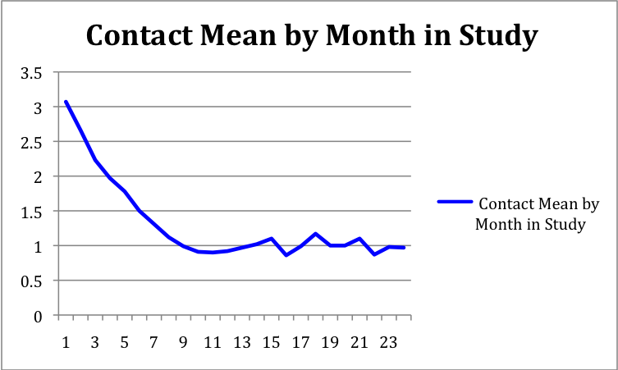
Month
Figure 2: Mean follow-along contacts aggregated across 6-month intervals comparing dropout participants to non-dropout participants
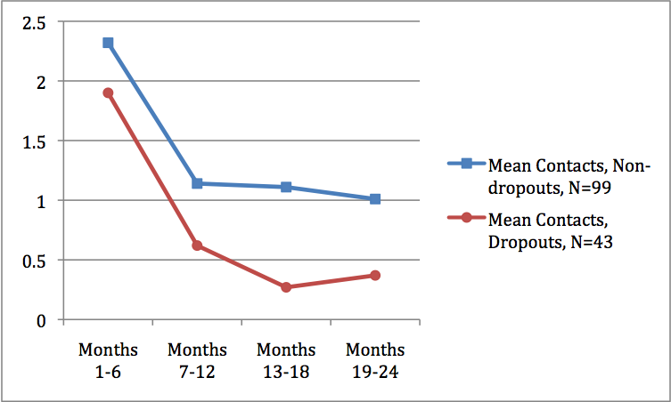

Figure 3: Mean mode of follow-along contacts aggregated across 6-month intervals, N=142
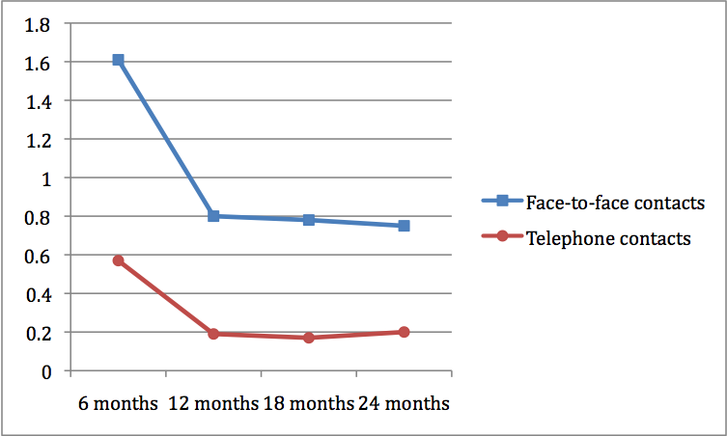

Figure 4: Mean location of follow-along contacts aggregated across 6-month intervals, N=142

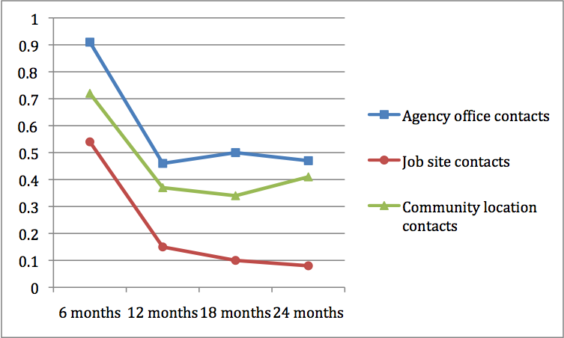

Figure 5: Mean duration of follow-along contacts aggregated across 6-month intervals, N=142

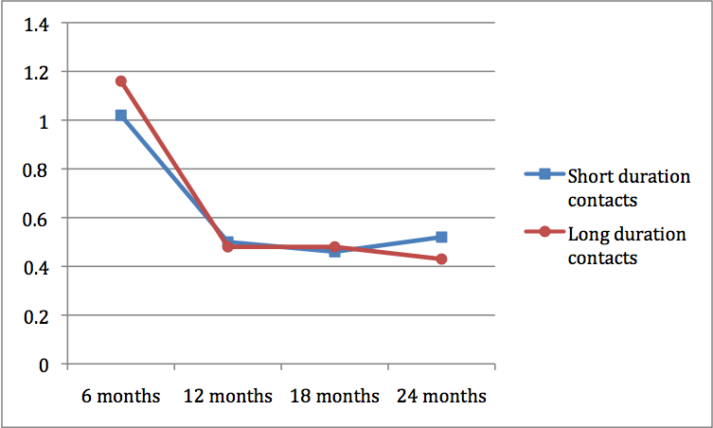

Figure 6: Number of follow-along contacts across the 24-month follow-up period by month in study for job tenure groups (those who worked the entire study period, N=21; those who held one job and experienced a job loss prior to 24 months, N=50; those who held multiple jobs, N=71)
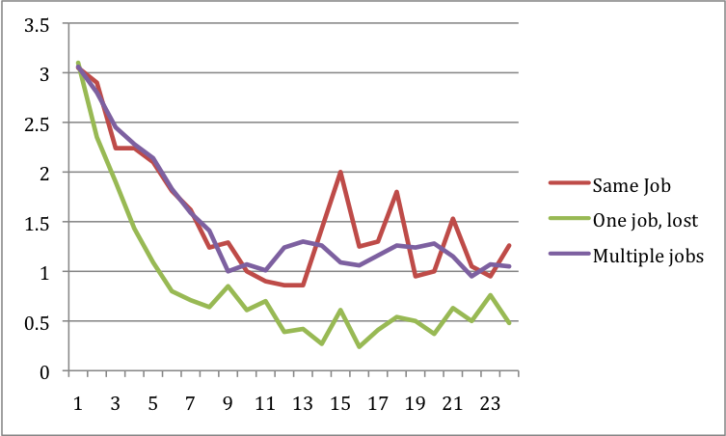
Month

Figure 7: Mean monthly follow along support according to study site

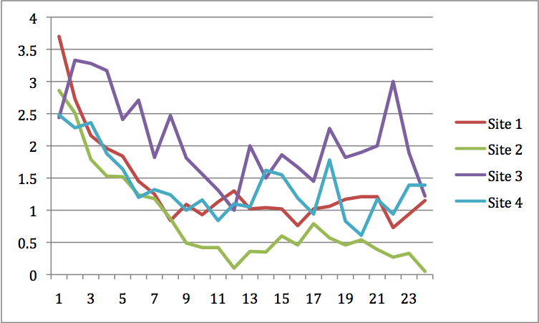

Figure 8: Scatterplot of mean follow along contacts and total months worked across all jobs, N=142
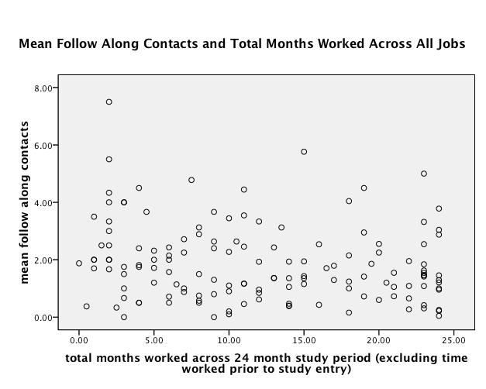

Figure 9: Scatterplot of mean follow along contacts and average months worked per job, N=142
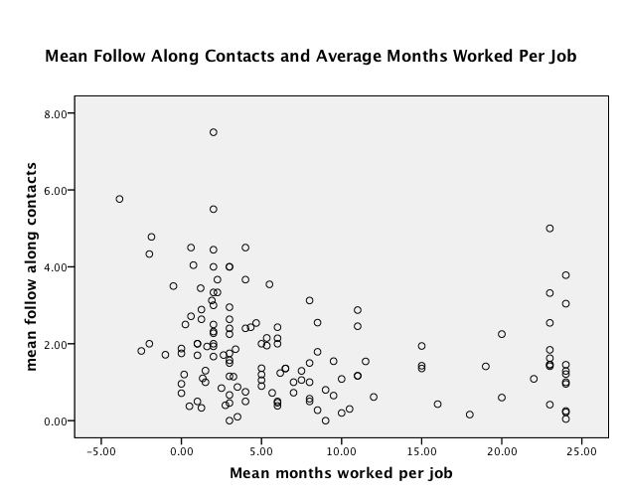

Figure 10: Scatterplot of mean follow along contacts and months worked at initial job, N=142
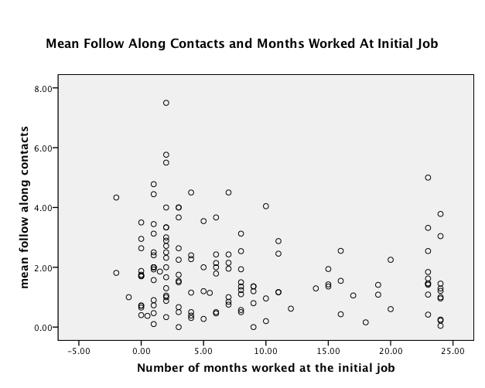

Figure 11: Scatterplot of mean follow along contacts and the number of months between the end of the initial , N=71
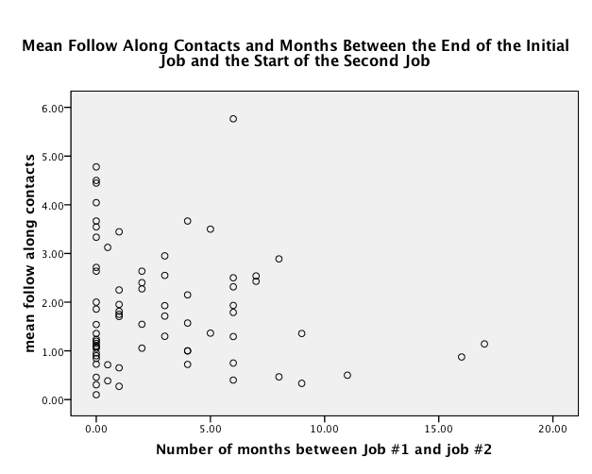

Figure 12: Survival Plot of the Number of Months until Initial Job Loss
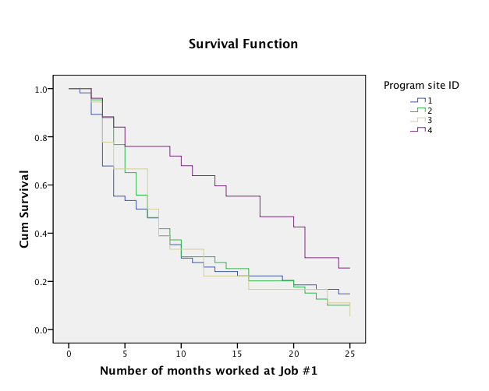

Figure 13: Survival Plot of the Number of Months until drop-out from the supported employment program by study site
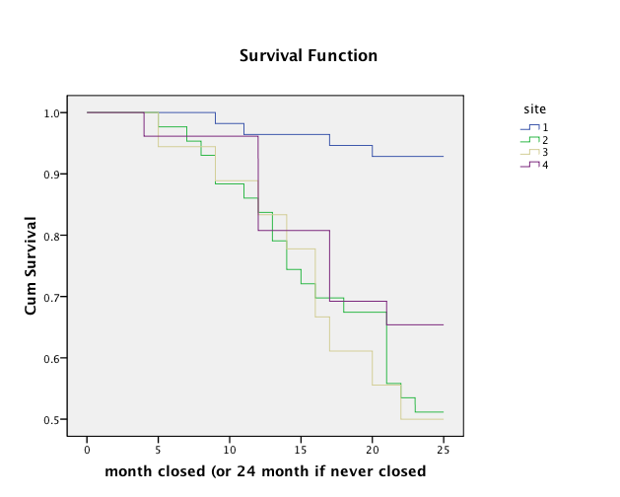

Figure 14: Survival Plot of the Number of Months until dropout from the supported employment program for the full sample, N=142
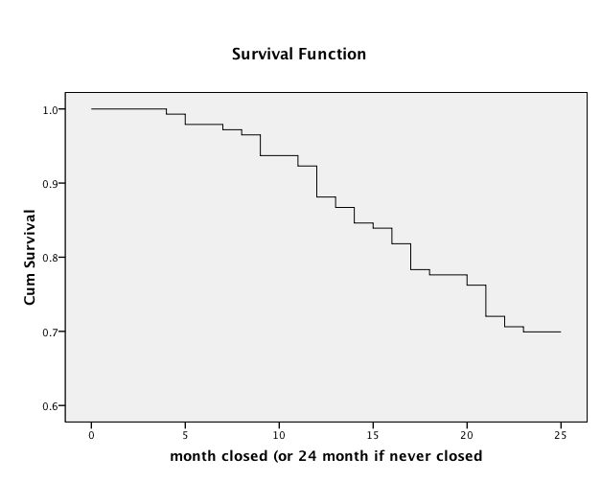

REFERENCES
Anderson, P. R. (1999). Open employment services for people with disabilities in Australia, 1995 to 1997. Journal of Vocational Rehabilitation, 13, 79-94.
Becker, D. R., & Drake, R. E. (2003). A working life for people with severe mental illness. New York: Oxford Press.
Becker, D. R., Drake, R. E., Farabaugh, A., & Bond, G. R. (1996). Job preferences of clients with severe psychiatric disorders participating in supported employment programs. Psychiatric Services, 47, 1223-1226.
Becker, D. R., Smith, J., Tanzman, B., Drake, R. E., & Tremblay, T. (2001). Fidelity of supported employment programs and employment outcomes. Psychiatric Services, 52, 834-836.
Becker, D. R., Swanson, S. J., Bond, G. R., Carlson, L., Flint, L., Smith, G., et al. (2008). Supported Employment Fidelity Scale. Lebanon, NH: Dartmouth Psychiatric Research Center (http://dms.dartmouth.edu/prc/employment/).
Becker, D. R., Whitley, R., Bailey, E. L., & Drake, R. E. (2007). Long-term employment outcomes of supported employment for people with severe mental illness. Psychiatric Services, 58, 922-928.
Becker, D. R., Xie, H., McHugo, G. J., Halliday, J., & Martinez, R. A. (2006). What predicts supported employment program outcomes? Community Mental Health Journal, 42, 303-313.
Birnbaum, M. H. (2004). Human research and data collection via the internet. Annual Review of Psychology, 55, 803-832.
Bond, G. R. (2004). Supported employment: Evidence for an evidence-based practice. Psychiatric Rehabilitation Journal, 27, 345-359.
Bond, G. R., Becker, D. R., Drake, R. E., & Vogler, K. M. (1997). A fidelity scale for the Individual Placement and Support model of supported employment. Rehabilitation Counseling Bulletin, 40, 265-284.
Bond, G. R., & Drake, R. E. (2008). Predictors of competitive employment among patients with schizophrenia. Current Opinion in Psychiatry, 21, 362-369.
Bond, G. R., Drake, R. E., & Becker, D. R. (2008). An update on randomized controlled trials of evidence-based supported employment. Psychiatric Rehabilitation Journal, 31, 280-290.
Bond, G. R., Drake, R. E., Mueser, K. T., & Becker, D. R. (1997). An update on supported employment for people with severe mental illness. Psychiatric Services, 48, 335-346.
Bond, G. R., & Kukla, M. (2008). Service intensity and job tenure in supported employment. In P. Wehman, J. Kregel & V. Brooke (Eds.), Research in review (pp. 145-155). Richmond, VA: Virginia Commonwealth University.
Bond, G. R., McGrew, J. H., & Fekete, D. M. (1995). Assertive outreach for frequent users of psychiatric hospitals: A meta-analysis. Journal of Mental Health Administration, 22, 4-16.
Bond, G. R., Miller, L. D., & Dietzen, L. L. (1992). Final report on SSA Supported Employment Project for SSI/SSDI Beneficiaries with Serious Mental Illness (Social Security Administration Grant No. 12-D-70299-5-01).
Bybee, D., Mowbray, C. T., & McCrohan, N. M. (1996). Towards zero exclusion in vocational opportunities for persons with psychiatric disabilities: Prediction of service receipt in a hybrid vocational/case management service program. Psychiatric Rehabilitation Journal, 19(4), 15-27.
Cook, J. A., Lehman, A. F., Drake, R., McFarlane, W. R., Gold, P. B., Leff, H. S., Blyler, C., Toprac, M. G., Razzano, L. A., Burke-Miller, J. K., Blankertz, L., Shafer, M., Pickett-Schenk, S. A., & Grey, D. D. (2005). Integration of psychiatric and vocational services: A multisite randomized, controlled trial of Supported employment. American Journal of Psychiatry, 162, 1948-1956.
Drake, R. E., Becker, D. R., Bond, G. R., & Mueser, K. T. (2003). A process analysis of integrated and non-integrated approaches to supported employment. Journal of Vocational Rehabilitation, 18, 51-58.
Drake, R. E., Becker, D. R., Goldman, H. H., & Martinez, R. A. (2006). Best practices: The Johnson & Johnson—Dartmouth Community Mental Health Program: Disseminating evidence-based practice. Psychiatric Services, 57, 302-304.
Drake, R. E., & McHugo, G. J. (2003). Large data sets can be dangerous! Psychiatric Services, 54, 133.
Fraser, V. V., Jones, A. M., Frounfelker, R., Harding, B., Hardin, T., & Bond, G. R. (2008). VR closure rates for two vocational models. Psychiatric Rehabilitation Journal, 31, 332-339.
Gervey, R., & Kowal, R. (1995). Job development strategies for placing persons with psychiatric disabilities into supported employment jobs in a large city. Psychosocial Rehabilitation Journal, 18(4), 95-113.
Grimshaw, J. M., Shirran, L., Thomas, R., Mowatt, G., Fraser, C., Bero, L., Grilli, R., Harvey, E., Oxman, A., & O'Brien, M. A. (2001). Changing provider behavior: an overview of systematic reviews of interventions. Medical Care, 39(8 Suppl 2), II2-II45.
Hannah, G., & Hall, J. (2006). Employment and mental health service utilization in Washington State. Journal of Behavioral Health Services and Research, 33, 287-303.
Huff, S. W. (2005). Closing the revolving door: Job match and workplace climate as predictors of long-term work success for persons with psychiatric disabilities. Unpublished dissertation, University of Kansas, Lawrence, KS.
Huff, S. W., Rapp, C. A., & Campbell, S. R. (2008). “Everyday is not always Jell-O”: A qualitative study of factors affecting job tenure. Psychiatric Rehabilitation Journal, 31, 211-218.
Jones, C. J., Perkins, D. V., & Born, D. L. (2001). Predicting work outcomes and service use in supported employment services for persons with psychiatric disabilities. Psychiatric Rehabilitation Journal, 25, 53-59.
Leff, H. S., Cook, J. A., Gold, P. B., Toprac, M., Blyler, C., Goldberg, R. W., McFarlane, W., Shafer, M., Allen, I. E., Camacho-Gonsalves, T., & Raab, B. (2005). Effects of job development and job support on competitive employment of persons with severe mental illness. Psychiatric Services, 56, 1237-1244.
MacDonald-Wilson, K. L., Revell, W. G., Nguyen, N. H., & Peterson, M. E. (1991). Supported employment outcomes for people with psychiatric disability: A comparative analysis. Journal of Vocational Rehabilitation, 1, 30-44.
McGrew, J. H. (2007). IPS fidelity survey of 17 supported employment programs in Indiana: Final report to SECT Center. Indianapolis: Indiana University-Purdue University Indianapolis.
McGuire, A. (2005). The effect of service on success in a supported employment program. Unpublished masters thesis, Indiana University-Purdue University Indianapolis, Indianapolis.
McGurk, S. R., & Mueser, K. T. (2006). Strategies for coping with cognitive impairment in supported employment. Psychiatric Services, 57, 1421-1429.
McGurk, S. R., Mueser, K. T., Harvey, P. D., La Puglia, R., & Marder, J. (2003). Cognitive and symptom predictors of work outcomes for clients with schizophrenia in supported employment. Psychiatric Services, 54, 1129-1135.
McHugo, G. J., Drake, R. E., & Becker, D. R. (1998). The durability of supported employment effects. Psychiatric Rehabilitation Journal, 22(1), 55-61.
Mueser, K. T., Aalto, S., Becker, D. R., Ogden, J. S., Wolfe, R. S., Schiavo, D., Wallace, C. J., & Xie, H. (2005). The effectiveness of skills training for improving outcomes in supported employment. Psychiatric Services, 56, 1254-1260.
Murphy, A. A., Mullen, M. G., & Spagnolo, A. B. (2005). Enhancing Individual Placement and Support: Promoting job tenure by integrating natural supports and supported education. American Journal of Psychiatric Rehabilitation, 8, 37-61.
Roberts, M. M., & Pratt, C. W. (2007). Putative evidence of employment readiness. Psychiatric Rehabilitation Journal, 30, 175-181.
Rogers, E. S., MacDonald-Wilson, K., Danley, K., Martin, R., & Anthony, W. A. (1997). A process analysis of supported employment services for persons with serious psychiatric disability: Implications for program design. Journal of Vocational Rehabilitation, 8, 233-242.
Salyers, M. P., Becker, D. R., Drake, R. E., Torrey, W. C., & Wyzik, P. F. (2004). Ten-year follow-up of clients in a supported employment program. Psychiatric Services, 55, 302-308.
Solberg, L. I. (2000). Guideline implementation: what the literature doesn't tell us. Joint Commission Journal on Quality Improvement, 26, 525-537.
Test, D. W., & Wood, W. M. (1996). Natural supports in the workplace: The jury is still out. Journal of the Association for Persons with Severe Handicaps, 21, 155-173.
Tsai, J., & Bond, G. R. (2007). A comparison of electronic medical records to conventional paper records in community mental health centers. International Journal for Quality in Health Care Advance Access published on December 12, 2007.
Wallace, C. J., & Tauber, R. (2004). Supplementing supported employment with workplace skills training. Psychiatric Services, 55, 513-515.
Wehman, P. (1986). Supported competitive employment for persons with severe disabilities. Journal of Applied Rehabilitation Counseling, 17, 24-29.
Zito, W., Greig, T. C., Wexler, B. E., & Bell, M. D. (2007). Predictors of on-site vocational support for people with schizophrenia in supported employment. Schizophrenia Research, 94, 81-88.

