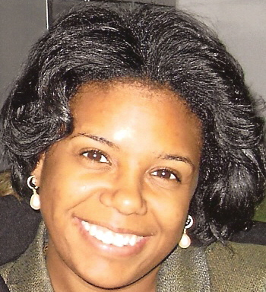

Kelli Williams Gary, Ph.D., MPH, OTR/L is a clinical researcher at Virginia Commonwealth University (VCU) and has been a licensed occupational therapist for 14 years. In 1990, Dr. Gary sustained a severe traumatic brain injury (TBI) in a motor vehicle accident and has overcome cognitive and physical deficits to obtain a Bachelor of Science degree in occupational therapy from Chicago State University in Chicago, IL, a Masters of Science and Masters of Public Health from Columbia University in New York, NY, and a Ph.D. from VCU in Richmond, VA after her injury. Prior to completion of her Ph.D., she worked as a staff occupational therapist in the Veterans Administration (VA) and academic medical centers in Chicago, New York, and Philadelphia. She has co-facilitated psychotherapy groups for veterans at Lakeside VA Hospital in Chicago, IL. In addition, she was a clinical rehab director for a skilled long term care company where she supervised occupational, physical and speech therapists while she was responsible for generating $325,000 in revenue per year. She completed a National Institute on Disability and Rehabilitation Research (NIDRR) pre-doctoral research fellowship at VCU, Department of Physical Medicine and Rehabilitation, Neuropsychology Division from 2005-2008. She has published eight articles in peer reviewed medical and rehabilitation journals (2 as a first author) on post-injury outcomes following TBI for racial and ethnic minorities and their caregivers and presented on these topics nationally and internationally. Currently, she is a post-doctoral research trainee on a grant entitled “Project Empowerment: Building Minority Research Capacity” at VCU in the Dept. of Rehabilitation Counseling. Dr. Gary is also the Vice-Chair of the Virginia Brain Injury Council and co-facilitates a brain injury support group for the Brain Injury Association of Virginia (BIAV).

