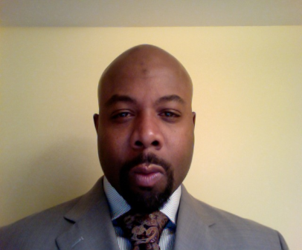

Mark A. Richardson, M.Ed. is currently a Ph.D. Candidate and Doctoral Research Assistant in the Department of Rehabilitation Counseling at Virginia Commonwealth University. Formerly the Coordinator for Programs for Adults in Vocational Education at J. Sargeant Reynolds Community College, where he directed and managed the development, evaluation and implementation of post-secondary vocational programs for students with intellectual disabilities. Mr. Richardson has had a longstanding commitment to working with students and adults with disabilities. Prior to joining the Department of Rehabilitation Counseling team, he worked as a Supported Employment Counselor, Community College Connection Specialist and Behavioral Consultant with Richmond Public School and Virginia Commonwealth University. His research interests include African American male mental health, ex-offender rehabilitation, the disproportionate disability labeling of minority students, universal design for instruction in the classroom and the effective use of special accommodations in post secondary environments.

